Then after you pick the PRINT button on the bottom you should see this:

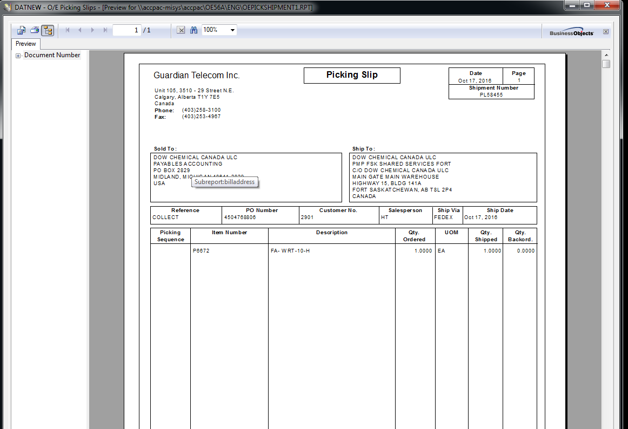

THE ERROR IS ….. HE SEE’S THIS:

