Payments Acceptance – Invoicing, Receipts, and lump sum Deposits

If you use Payments Acceptance, your customers can pay invoices through online providers such as PayPal or Stripe. After your customers make online payments, you download and reconcile receipts for those payments.

Due to the timing of invoices being paid, payments being downloaded into Sage 300, and actual lump-sum deposits being made by providers, you should establish processes for downloading and reconciling receipts for online payments. This document presents an example of a process you might follow. In this example:
- You have a customer who makes two online payments:
  - Inv#1 $100
  - Inv#2 $200
- The provider charges a processing fee of 2% on the online payments. (This fee is based on the agreement between you and the provider. The fee you actually pay may not be 2%.)

Example of process for downloading and reconciling receipts for online payments

- You post and email two invoices to your customer:
- Inv#1
Debit Accounts Receivable $100
Debit Cost of Sales 55
Credit Sales $100
Credit Inventory 55
- Inv#2
Debit Accounts Receivable $200
Debit Cost of Sales 120
Credit Sales $200
Credit Inventory 120
- Your customer pays both invoices.
The two AR Invoices are fully applied (settled for $100 and $200 respectively). No real money has changed hands yet so need to set up a ‘clearing’ bank to handle the transition. For the AR Receipt Entries, Online Receivable Clearing will get $294 ($98 and $196). The fee expenses of $6 ($2 and $4) will be Bank Entries.
- You create the ‘clearing’ bank as below. (This ‘clearing’ Bank Account could be a Bank or Receivable GL account.)
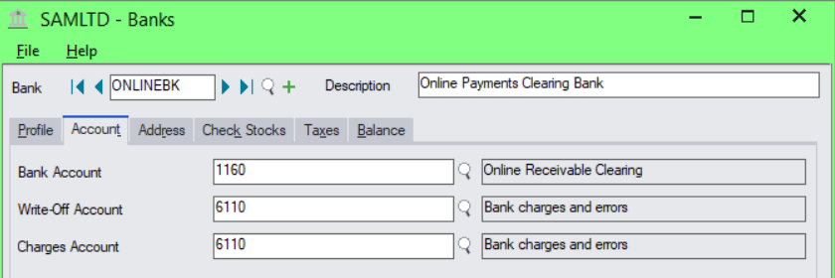

- Set this Bank Code in A/R Options so that Receipts will be recorded to it.
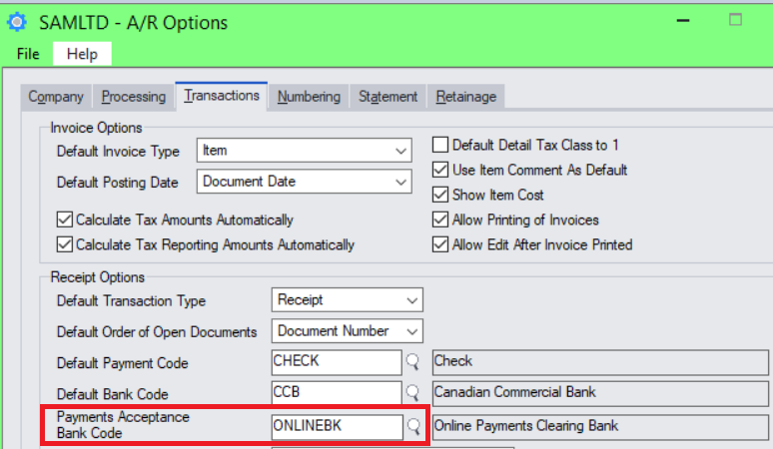
- Inv#1
  - AR Receipt Entry:
Debit Online Receivable Clearing $100
Credit Accounts Receivable $100
  - Bank Entry:
Debit Online Payments Fee Expense $2
Credit Online Receivable Clearing $2
- Inv#2
  - AR Receipt Entry:
Debit Online Receivable Clearing $200
Credit Accounts Receivable $200
  - Bank Entry:
Debit Online Payments Fee Expense $4
Credit Online Receivable Clearing $4
- The provider makes a lump-sum deposit to your bank of $294 (the deposit excludes the $6 in fees).
- You enter a Bank Transfer Entry to clear out the Online Receivable Clearing and finally debit the amount onto the real Bank Account.
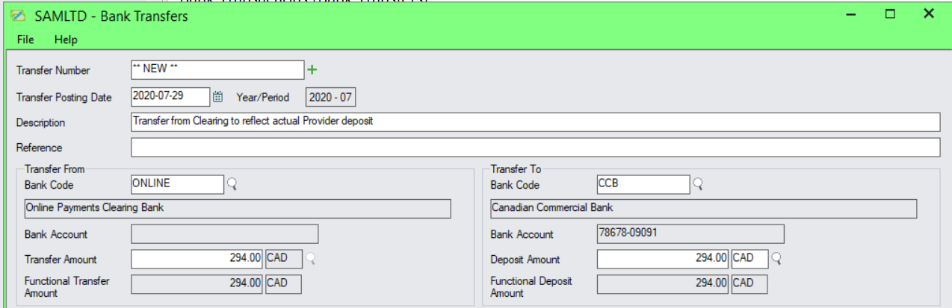

Debit Bank $294
Credit Accounts Receivable Clearing $294

- Use bank feeds to get the $294 lump-sum deposit from your bank. Match and clear the transaction (deposit) to complete bank reconciliation for the bank.

