Sage Pastel Support Document
Creating Recurring Customer Invoices

Sage Pastel Support Document
Offline Point of Sale

OFFLINE POINT OF SALE
- POS works in “real time”, which means basically you cannot work in a future or past date.
POS uses the system date. A shift cannot have more than one date in it. POS will differentiate the transactions with different dates to different shifts. (different from a session). The dates also need to fall within the financial year of the data you have open.

- For POS to link to Accounting a Microsoft Access database was created (Documents.mdb)
All POS transaction get posted into this database and then into Accounting.
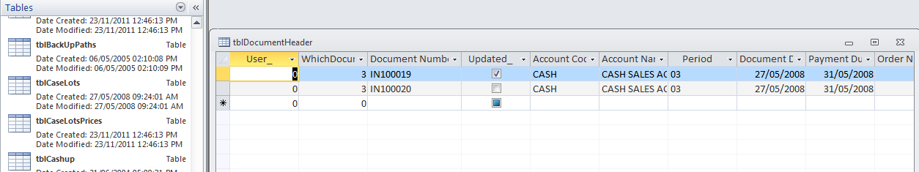

- In offline POS the data gets posted from Documents.mdb to Accounting only when you “FETCH” the transactions and update the transactions in POS.

- Initial setup for Offline POS and Online POS is exactly the same until you activate the offline option. You have to select “Enable offline Processing” (Picture 1) before you can select “Offline Options” (Picture 2).

Picture 1
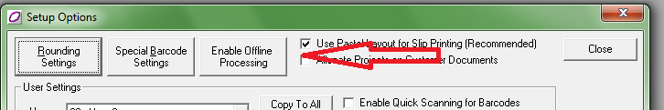

Picture 2
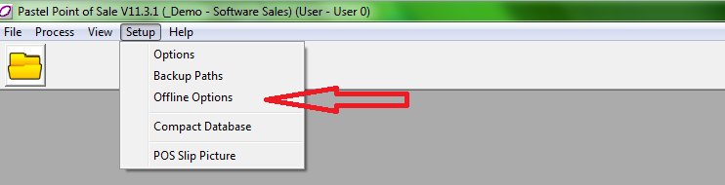

Offline Point of Sale enables the user to process POS transactions even when they are not physically connected to the main data server.
The main set of accounts (company structure) would need to be set up and deployed (copied) via the Process | Offline Management option in the Point Of Sale program. This must be done from the POS Supervisor computer to the various terminals at the outset.
Point of Sale processing can then continue on each POS station, whilst the POS Supervisor can continue normal accounting processing in Pastel.

At a convenient time, the POS Supervisor would ‘fetch’ the Point of Sale transactions from all the terminals, or selected intervals. As you may not want to ‘fetch’ data from every terminal, the system will record which terminals have or have not had the transactions ‘fetched’. The main set of accounts would then be updated and the POS Supervisor is then able to cash up and update all the new sales information.
Once the POS Supervisor has completed this processes, the updated set of accounts will be deployed back to the terminals from where the data was ‘fetched’.
If data is not ‘fetched’ from a specific terminal, the system will not deploy back to that terminal until the transactions have been ‘fetched’.
Important points to take note of:
It is extremely important that you familiarise yourself with the following points before installing Offline POS:

- Cash On Delivery (CODs): CODs are stored on the terminal where they are created. Therefore, it is imperative that the customer be told that if they use CODs, the driver/customer must return to the till where the COD was raised. If this is a problem, the client will need to consider going back to online POS processing. This rule also applies to Quotations, Sales Orders, and Documents ‘On Hold’.

- Offline POS is not intended for WANs (Wide Area Networks), and is therefore not suitable for running across branches. Offline POS is new technology which allows tills to be disconnected from the server during normal day processing. It is specifically designed for environments where customers cannot afford down time, and encounter network problems or connectivity problems during the normal course of the day. Therefore, with Offline POS, customers will still require Pastel Accounting and their own set of accounts per branch.

- On the terminal, under the PastelPOS directory, a file named TillID will exist in the company folder. This file identifies which terminal this specific computer is, and must not be tampered with whatsoever.
- If deploying or fetching fails, do not manually copy any files or delete any files. Resolve the error received during deploying or fetching without tampering with any of the background files.

- A customer cannot run some terminals offline, and others online. The POS system may only run entirely offline, or entirely online.

- The terminal that is selected for supervisor processing can only do the back office POS supervisor processing and cannot process POS transactions (invoices, CODs etc).

- The POS Supervisor terminal requires a POS user count, therefore include 1 user count into the total number of terminals required to determine your total user count. For example, if the customer has 3 POS terminals, you will require 4 users in total (3 for the terminals, and 1 for the POS Supervisor).

- If the customer has the Serial Number Tracking module, items that are serialised will be blocked and will not be able to be processed in Offline POS.
- No supplier processing will be available at the Offline POS terminals.

Registration
Registration will take place on the server and when first deploying the company to the POS terminals; the terminals will automatically be registered.
Basic steps for Offline POS installation
1. Install Pastel Partner on the server which will also install Pastel POS.
2. Install Pastel POS on each terminal using the Point Of Sale-only install, found in the Products folder of your
Pastel installation CD/DVD.
3. Share the PastelPOS folder on each terminal with Reading/Writing rights
4. Map a network drive from the server to each terminal to the PastelPOS folder
5. On the server:
- Create a user in Pastel for each POS terminal
- Ensure each user is set up in batch mode and not on completion of document
- Open the company through POS:
- Setup the user settings
- Setup the offline terminals
- Ensure that all the necessary form files (eng/enz) are in the company folder
- For till slips, it will be frmislip, frmislipvat, frmreceipt, cslip, cslipvat, cslipreceipt.
- If the client does not require till slips to be printed, copy the normal Pastel files (csdoc, or the form that you have setup).
- Deploy the company through offline management in POS to all the terminals. You can do this by following the instructions below :
- Select Process | Offline Management. Select the POS terminal and click Deploy.

- Offline Options
This is where you setup the links between the Server and the POS tills.
You need to capture:
- Terminal Name (Computer name)
- Terminal Path. (P:\PASPOS)This will be the map drive you make from the Server to the PASPOS folder on the workstation. The PASPOS folder is in the Pastel folder on a workstation where you have installed offline POS. PASPOS folder stores the documents.mdb file on the workstation.

- In the document number fields, specify the document numbers to use at that terminal. You must ensure that your document numbers are unique across the whole system. Which also means in Accounting you have to make sure you have set Pastel to use “Separate Set Of Numbers” for each document and “Update in Batch Mode” for each POS user.

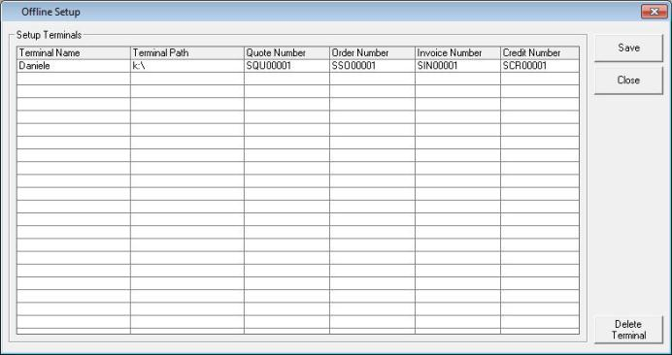
Fetching and Deploying
Setting up Terminal Paths and Fetching/Deploying are the only times Offline POS needs to be Online. The Fetching/Deploying uses the Terminal Paths to do its thing.

- Both processes are done by the POS supervisor on the server
- Deploying sends POS data to the workstation
- Fetching retrieves POS data from the workstation
- After setting up the terminals you will be able to go to Process Offline Management
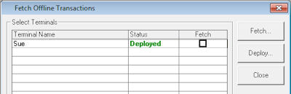

To deploy and fetch data
- Each terminal displays. There are three possible status settings:
- Not Deployed means this is a new terminal that is not yet in use.
- Deployed means you have sent data to the terminal, and the operator can process sales.
- Fetched means you have retrieved the data from the terminal. The operator cannot process until you deploy again.

To deploy data
- Click the Deploy.
- If you already have deployed to a terminal, the system does not deploy to that terminal again.
To fetch data
- Check the Fetch check box of those terminals you wish to retrieve.
- Note that you need to fetch data from a terminal even if no work was done on that terminal.
- You cannot redeploy to a terminal until you fetch the data.
- Click the Fetch button.
- The system retrieves the data.
- Note that the system does NOT fetch documents on hold or CODs that are not yet complete.
- They remain on the terminal and will be there after you redeploy.

AFTER THIS YOU CAN GO OFFLINE
WORKSTATION CAN SELL
SUPERVISOR CAN CASH UP

