1. Captue a new PO as below and clcik the Place Ordr button when done.
In this case 10 units are ordred but only 8 units get confirmed at this stage
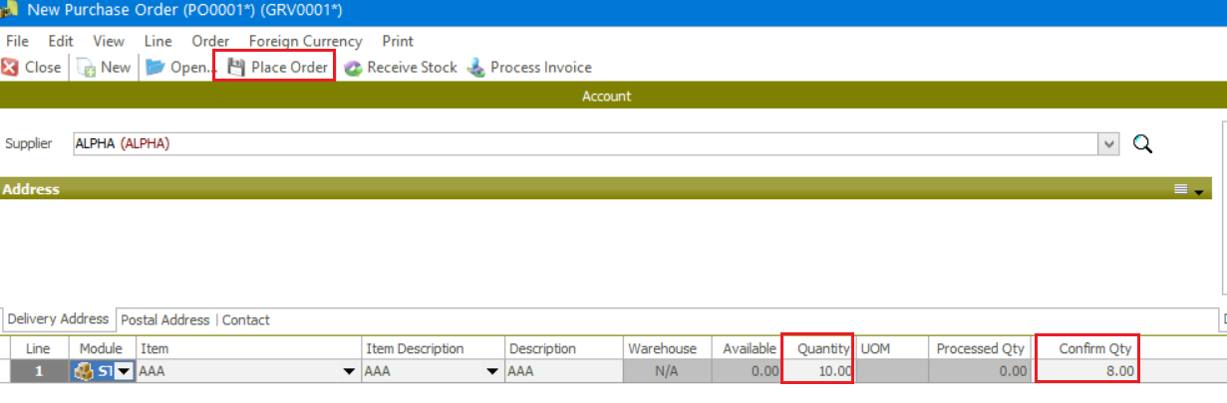
2. On the day that the stock arrives and you ready to process the GRV, open the Purchase Order Maintenance screen and find the PO you’re looking for using the Unprocessed Status as can be seen below. Open the PO when found.
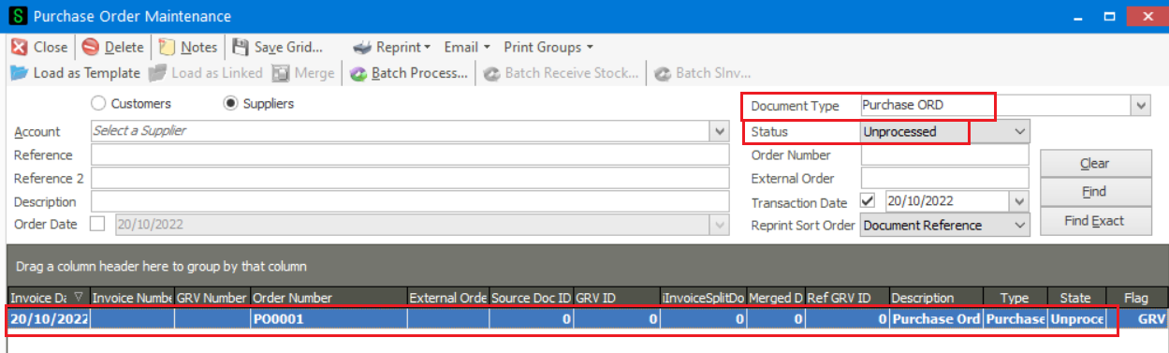
3. On the PO screen, process the GRV (Receive Stock) or SINV (Process Invoice) as relevant.
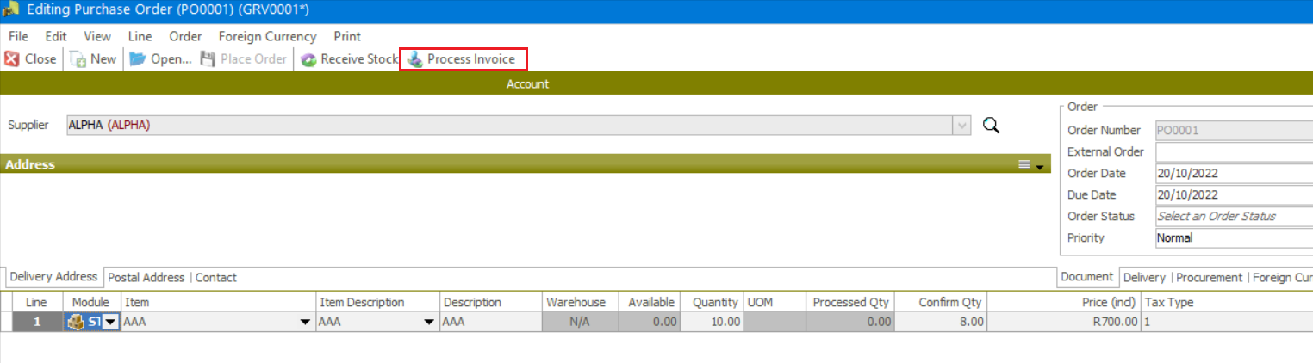
4. Let’s now find and view the partially processed PO that needs to be removed/closed off. Open the PO when found.
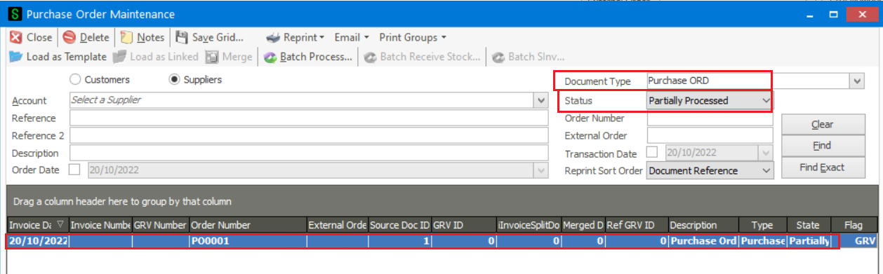
5. This is how the partially PO looks like as expected. If needed, you can still make changes and process further on it.
However, in this case the whole partially processed PO needs to be closed off / cancelled.
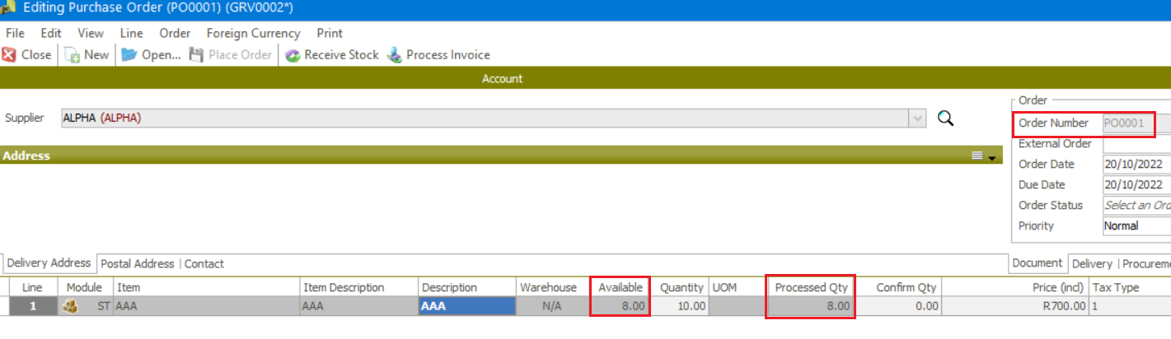
6. Therefore, go to Order Entry | Maintenance | Cancel Orders.
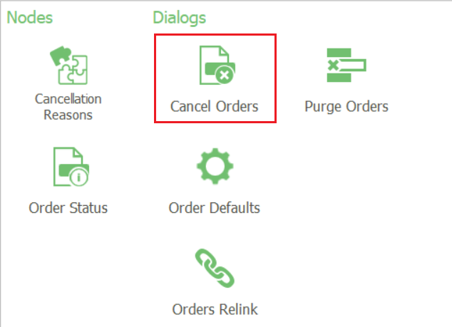
7. Setup the various parameters /filters to find the partially PO to select the range of PO’s that need to be closed off / cancelled.
Of course, you can make use of as many filters and filter values as required for a finer search of the PO’s that need to be closed off. When done, click the Start button
Also notice that you can even cancel unprocessed orders.
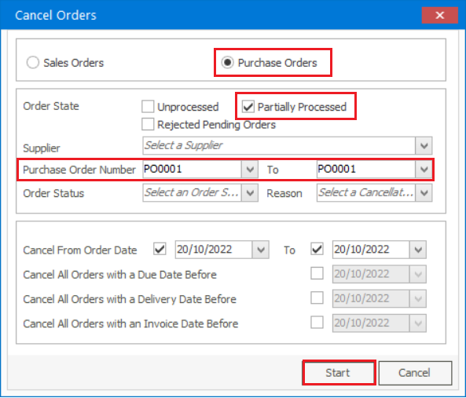
8. When done, click OK on the following message.
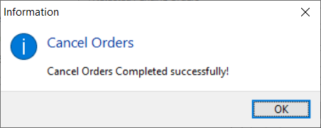
9. To review the results of the above action, find and view the cancelled PO by selecting the Cancelled Status below.
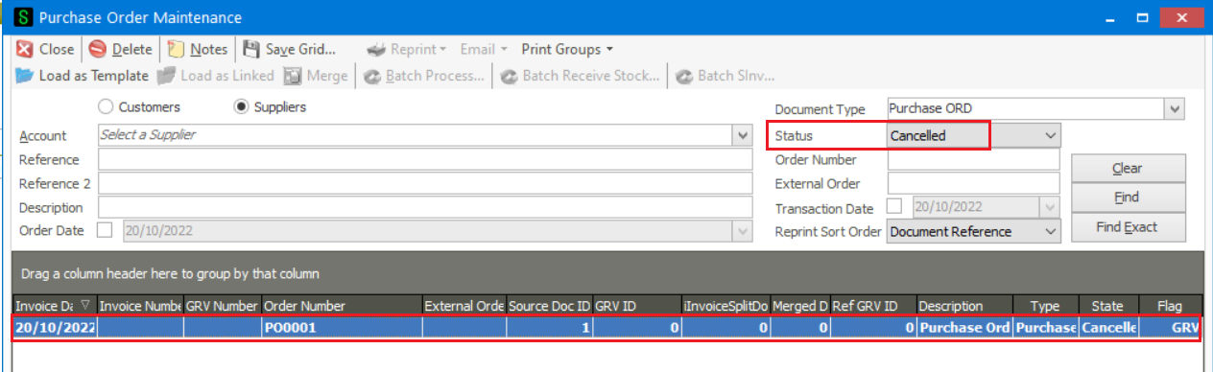
10. When opened, notice that no further actions/updated/processing can be performed on it.
Also, notice that cancelling orders leaves you with a ‘audit trial’ of all placed orders for your company data’s security and integrity. Doing it this way is of course a good way of protecting against fraudulent activities.
