1. Create this cashbook batch
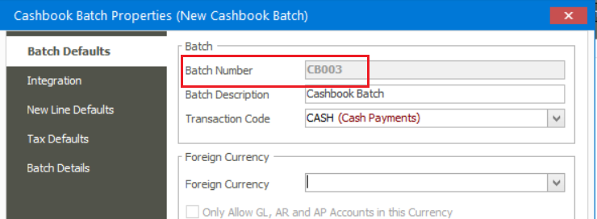
2. Capture and post this batch with these transaction lines’ dates
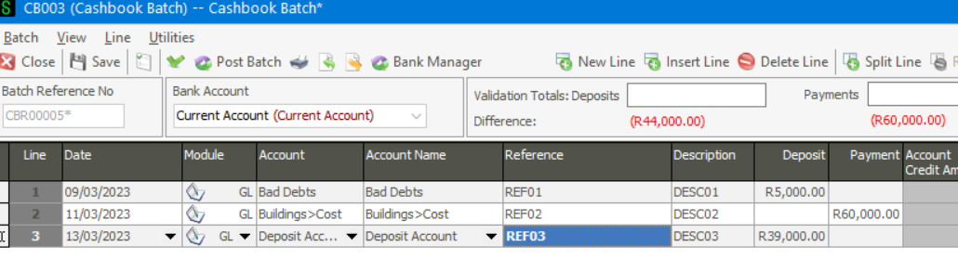
3. Print my Cashbook batch report
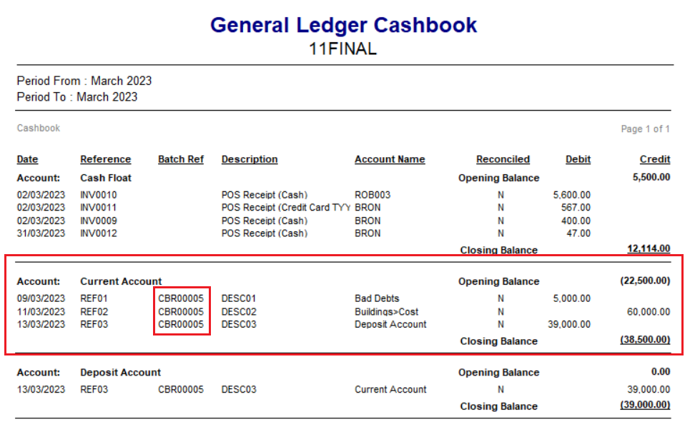

4. Go to Administration | Utilities | Change Batch
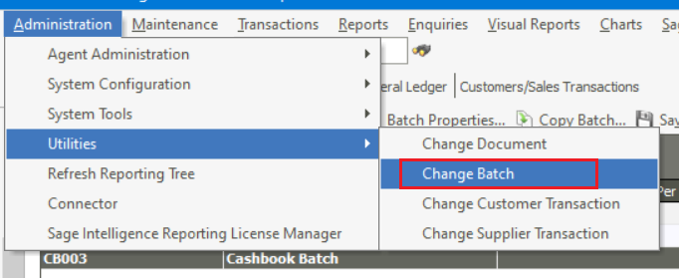
5. Select the correct Cashbook Batch Reference Number
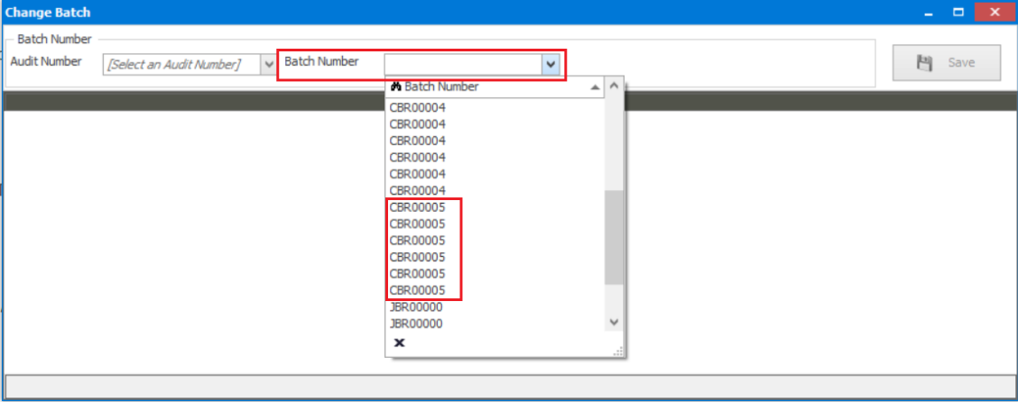
6. Notice the dates they were captured
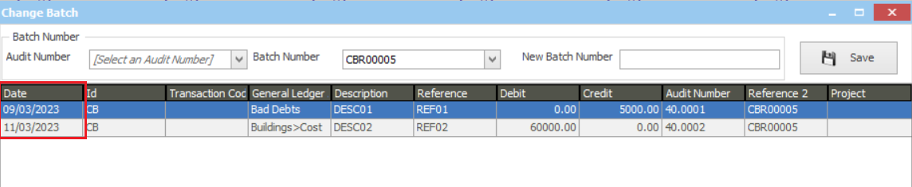
7. Select the correct date
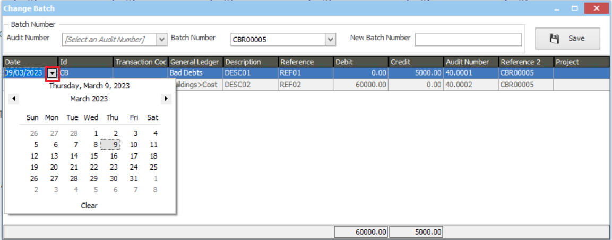

8. When done, save the change
