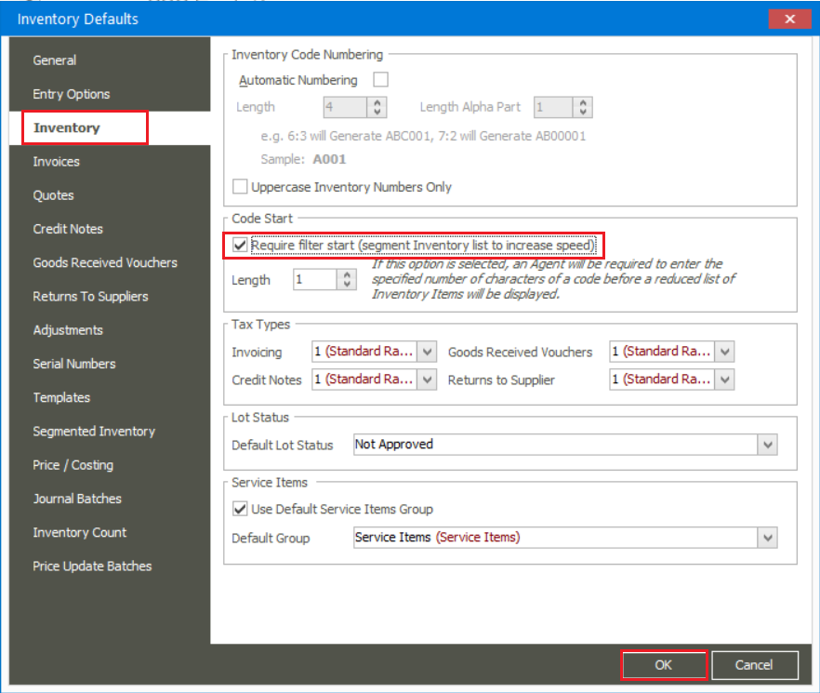
On the Inventory Item Grid, you will now need to enter 1 character before the stock items display on the grid
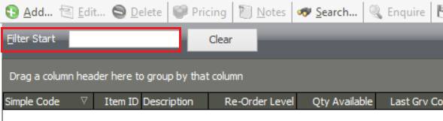
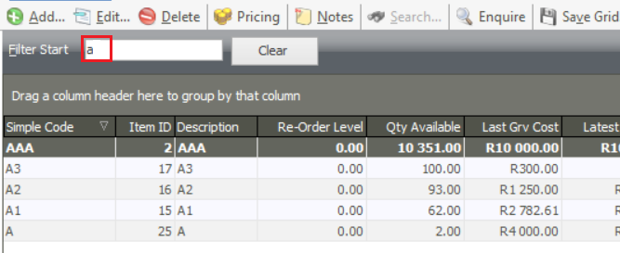
On the Bill Master screen, you should now also select at least the first character
