The following type of error message may be displayed when reprinting invoices or other documents:

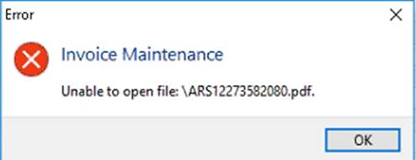

REASON AND SOLUTION

This error may be due to a corrupted Registry key on the local PC where the user is working on.

**To resolve this, do the following:**

1. Completely close Evolution on the local PC (not just minimising it).
2. Open the **Registry Editor** (type in **regedit** on the Start menu search field and enter on the keyboard) on the local PC.
3. Within the Registry Editor, go to **HKEY_CURRENT_USER\Software\Softline\Evolution\Agents**
4. Double click on the relevant agent working on the local PC, in this example: ADMIN
5. In case of an invoice having the error, find the **TfrmInvoice_012** key folder under ADMIN, right click on it and click on Delete.

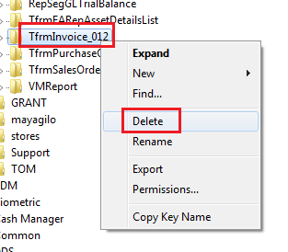

Also consider other documents’ Registry key folders that need to be deleted where relevant.  If you’re not sure which key to delete, please consult with Evolution Support.

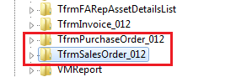

1. Close the Registry Editor and re-open the Evolution company to continue working.