1. Go to Inventory | Transactions | Price Update Batches
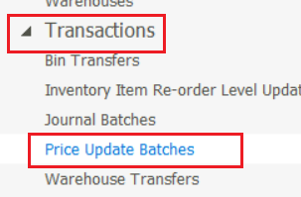
2. Create and then open the new batch
3. In here notice that you can import your new updates selling prices
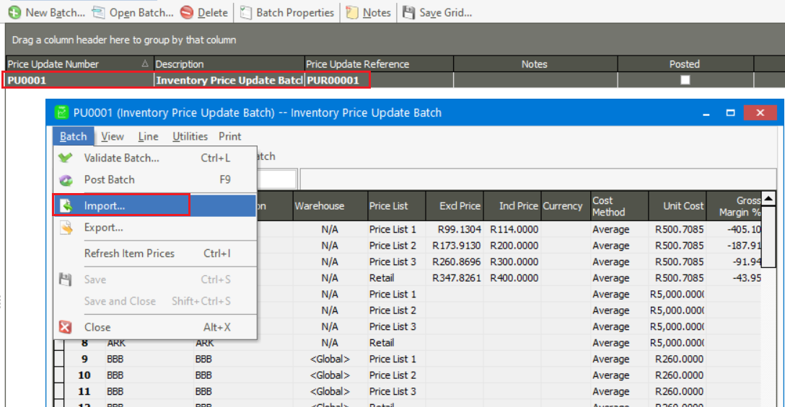
4. On this Batch Import screen setup the correct values and browse for your import file
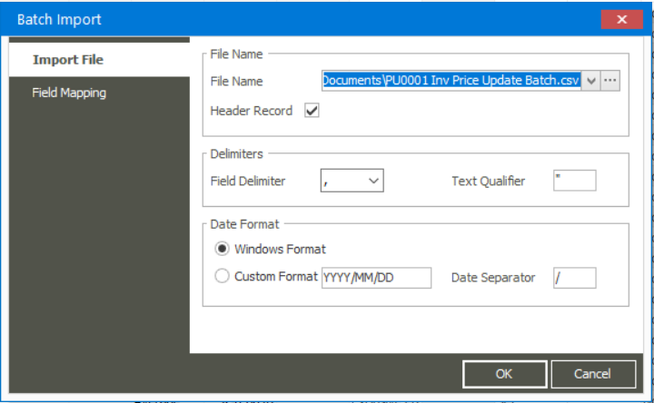

5. Also notice the Field Mapping screen where you configure the field mapping according to the field columns on your import file.
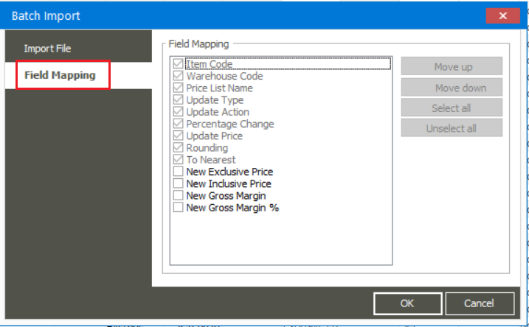

Note the following about your import file:
- The import file must be saved as a CSV format and comply to the following:
  - Have no ‘, “, , , /, \ characters on any cell in the spread sheet. Simply where possible, refrain from any special characters.

  - No hidden rows or columns

  - No open rows or columns

  - No formulae on any cells. Therefore, use the MS Excel copy and Paste Special /
Values option to end up with normal text/number fields
- When using Number or currency cell types in the import spread sheet, don’t use the thousand’s separator option on the Cell Properties

- Ensure there are no spaces after any values in any cells on the import file

  - Ensure all non-date field values uses the Text cell property.

  - Only include the fields in the import sheet that will eventually be imported, therefore no unnecessary columns that are not part of the data you eventually want in the company

  - The file must be closed before browsing for the import file

