1. Capture and process the SO (selecting REP01)
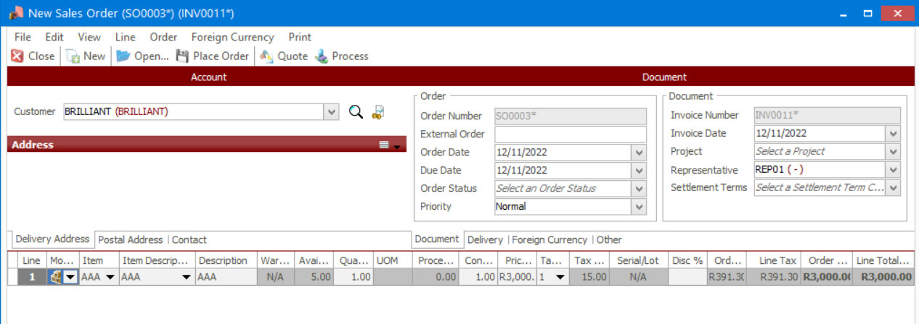
2. Go to Administration | Utilities | Change Document
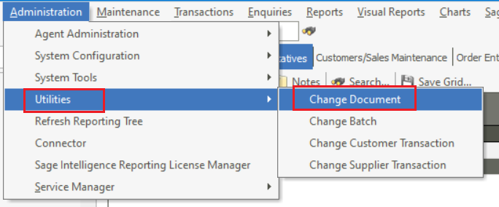
3. Find and select the Sales Order
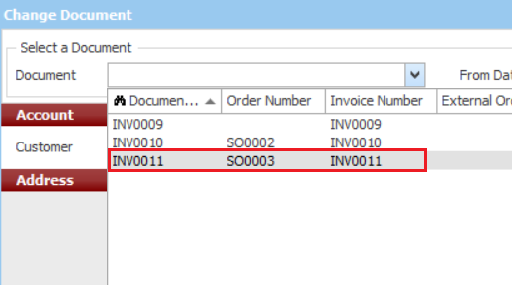

4. Change the Sales Rep
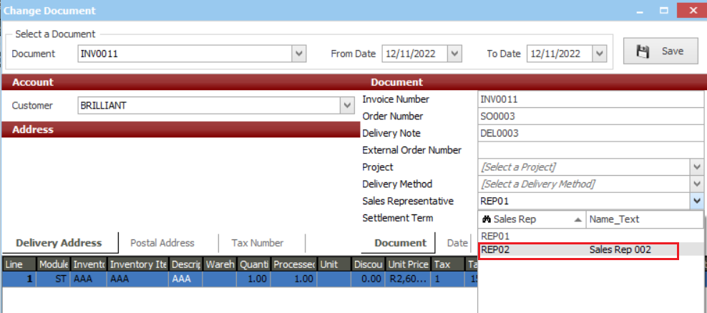
5. Click the Save button and then close the Utilities screen
