Client has complained about transactions being posted to the 2400 (Stock Cost Variance) GL Account.
This happens only when an RTS is posted.

Lets look at the below RTS.
It is quite straightforward. Not a foreign supplier nor does it have any Importation Split.
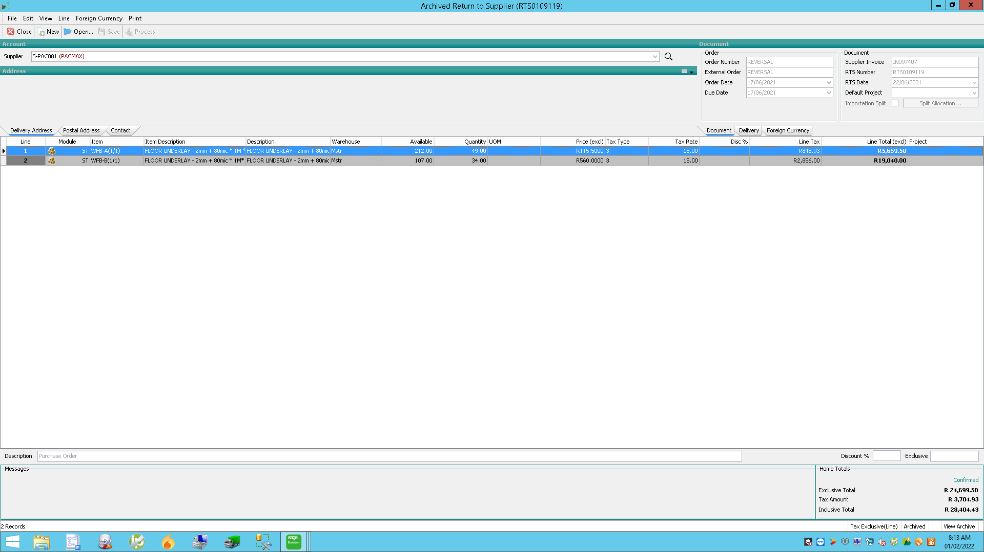

If I have to look at the transaction breakdown for this RTS, this is what appears:

You will notice there are 5 entries to the 2400 GL Account. This is what the client wants clarity on.

This is the GRV that was returned.
You will notice there is no variance between the purchase cost and the return cost.
