Correction of missing infos in AMIGKEY

The following info is the result of the CoEX-Ticket Coex-201, which was developed with Marc Ribas.
The following maintenances must be installed in the PU9 installation:

maintenance 3974 - JIRA X3-131583
maintenance 3589 - JIRA X3-90233

In the X3-folder in the table AMIGKEY a row with the information about the X3 version is missing.
This information is required when executing the pre-scripts for migration. If this information is missing, the error message mentioned above is displayed when executing the script UUMGPREX3.
You have to add it first via Script Editor. Then you have to add a value with the missing info about the version.

Initial Error message
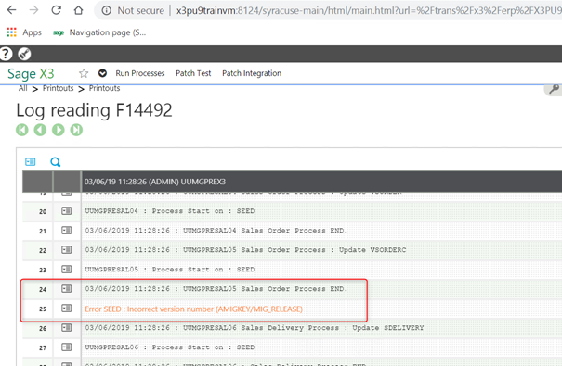

Missing row in the DB table AMIGKEY
Queries for getting informations
select * from X3.ADOVAL where PARAM_0='RELEASE'
select * from X3.AMIGKEY
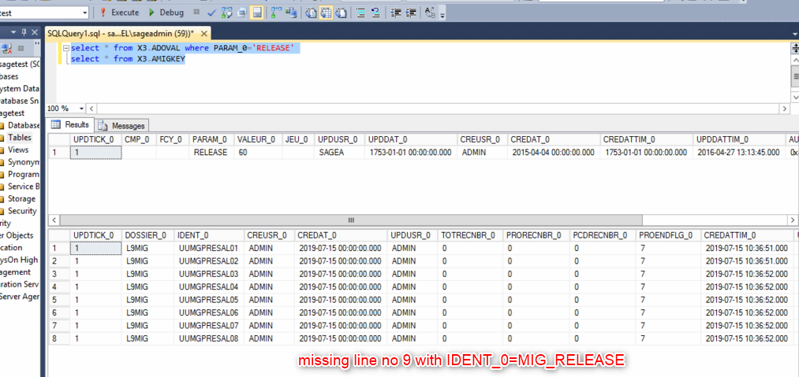

Solution
Step 1 - Create a row for the info with IDENT_0 = MIG_RELEASE
Call Script Editor in the folder to be migrated new name e.g. "ZMIG”
Insert the script below - Run the compilation
Execute the following script with the corresponding folder name e.g. SEED
$ZMIG
Local integrity MYERR
Call MIGSTKVERSION("Folder_Name", "0",MYERR) From TRTMIG
End
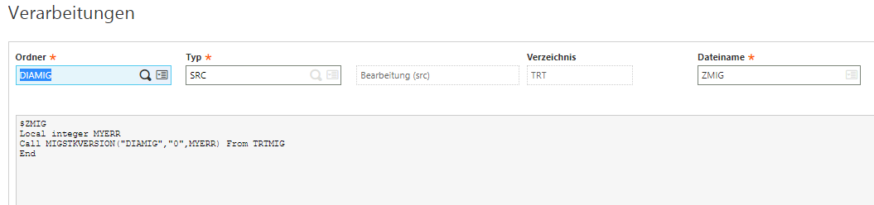

Step 2 - Adding the version info in the DB

The field TORECNBR_0 in table AMIGKEY has no value or 0 as a value. However, the version value for PU9 is 60.
The version number must be contained in the row that contains the value MIG_RELEASE in the column IDENT_0.
This info is displayed in the Management Console – folders - Release column
Example
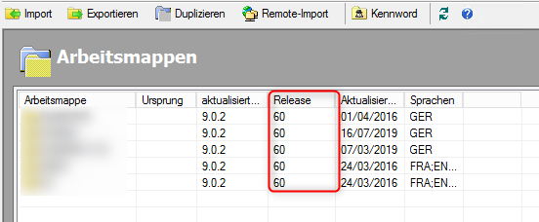

Queries
select * from X3.ADOVAL where PARAM_0='RELEASE'
select * from X3.AMIGKEY
update X3.AMIGKEY set TOTRECNBR_0='60' where IDENT_0='MIG_RELEASE'
