Step 1: Go to source table and check the boxes as required (CREATE/MODIFY/DELETE), check the workflow flag and list the fields to audit (conditions not required) . Remember to validate.
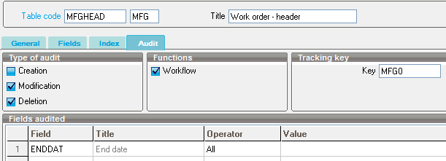

Step 2: Go to data model and modify UPDFLD (copy into new model) – linking desired table with AUDITH and AUDITL.

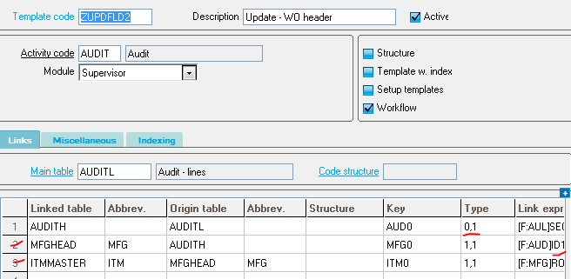

Step 3: Create the workflow rule (copy of UPDFLD pre-existing workflow) – with the necessary conditions (Check the data model correct). Setup as so (Note triggering = LINE)
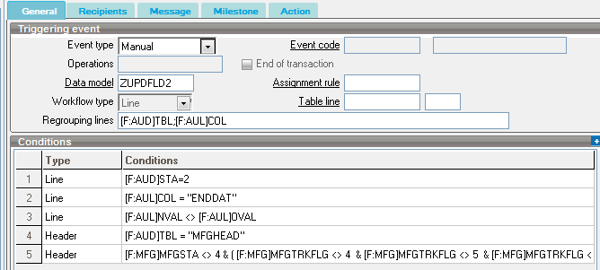
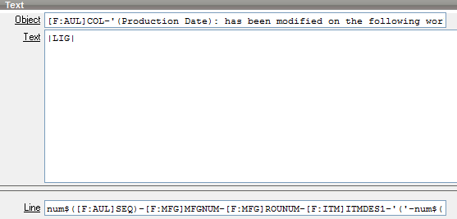
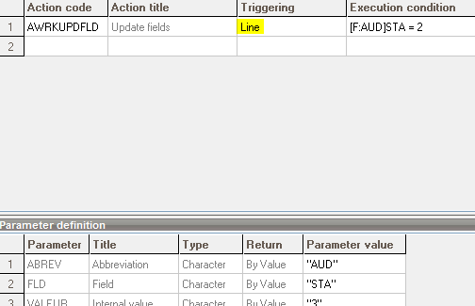
Step 4
To view audited fields not processing, go to Audit (CONSAUD) and sort by Status. These 3 lines should fire on the execution of SAIWKRMAN batch task we will set up in step 5:
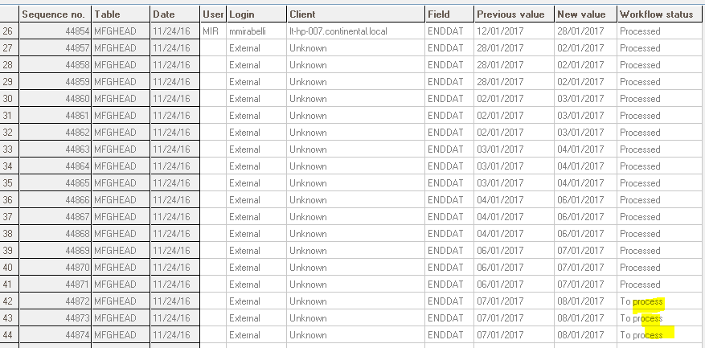
Step 5
Create a task that runs SAIWRKMAN at set intervals during day/week (will run automatically and send e-mail based on all fields audited (since last execution)
