V12 (only 2000 lines displayed)
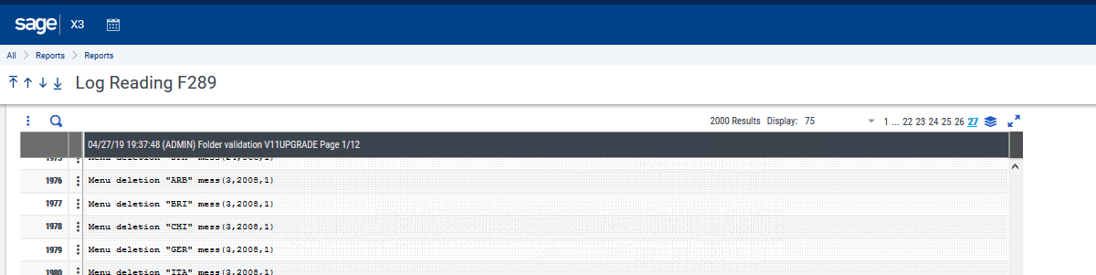
Actual end of the trace file (22936 lines)
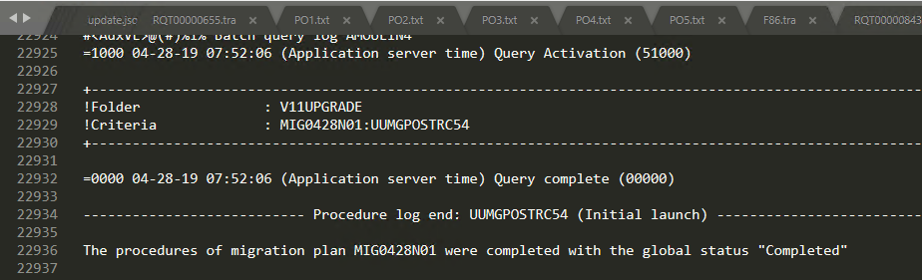

V11 (page 25 of 25, each page of 1000)
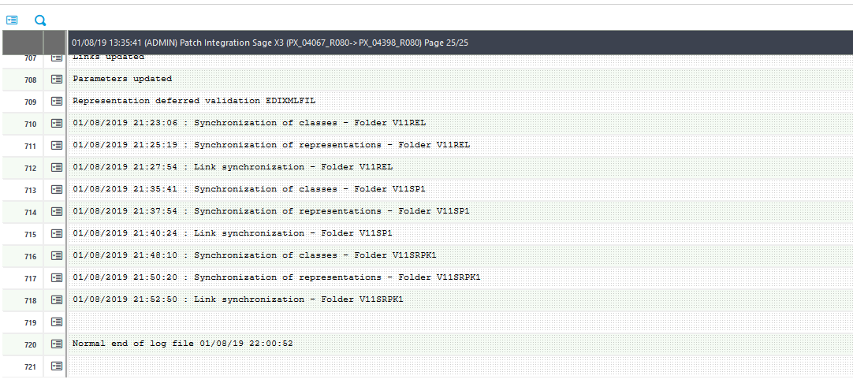
Actual end of the trace (24721 lines)
