Pastel Evolution Management Pack Consolidation

Objective: Our objective is to consolidate the financial information from multiple company databases into a single Management Pack. For this exercise we will be sourcing our data from Pastel Evolution databases but much the same logic will apply across all other accounting packages.

Consolidation options: Consolidations take various forms and are critical to management information today. At the same time, they are one of the most time consuming and cumbersome tasks. Pastel BIC is designed to cater for a variety of consolidation options, placing a wrapper around loose Excel spreadsheet use and guaranteeing data integrity and one version of the truth.
The one we will concern ourselves with here is consolidating similar information using a PickList. This allows you to access multiple companies’ at one time through one connection. The advantage of this method is that you can select which companies to report off on the fly. This method is best suited when consolidating like data. If your data is dissimilar then rather use the union reporting to consolidate.

A. Setting up a PickList
PickLists are set up in the “Database Name” textbox under Connections in the Pastel BIC Advanced Module.
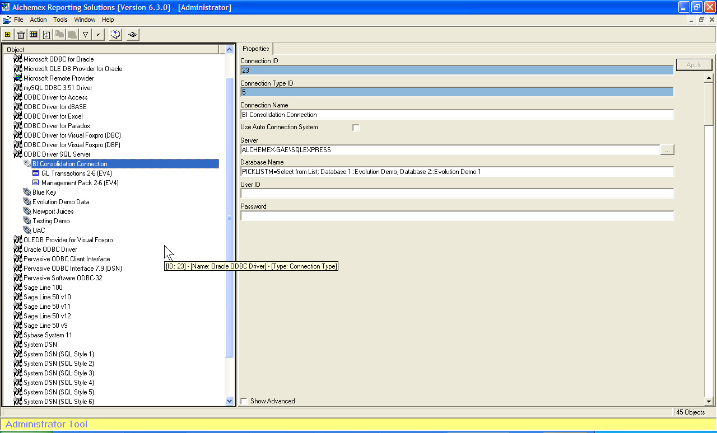
Let us assume that we have created a new connection called Consolidation Connection and have set up the connection details in the conventional way.
We now navigate to the “Database Name” textbox in the Properties pane and replace the existing database details with the following: -
PICKLISTM=Select from List;Database 1::Evolution Demo; Database 2::Evolution Demo 1;
This will give us a PickList showing two Company database connections A and B

Let us look at each component functions and the variables associated with it.
PICKLIST - has the following variables:
- PICKLIST= Presents you with a list of all connections but only allows you to select ONE – This will obviously not do for our consolidation Management Pack exercise.
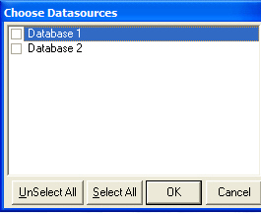
- PICKLISTA= Will automatically run ALL the connections listed in the PickList, thus no popup list to select from. This option is great for a consolidated Management Pack that consists of all the Companies in the list.
- PICKLISTM= Presents you with a list of all the connections and allows you the option of specifying which connections to run. Make your choice by checking one ore more of the check boxes next to your Company Names.
- PICKLISTDSN= Presents you with a list of all connections available DSN connections but only allows you to select ONE – This will obviously not do for our consolidation Management Pack exercise but is a very useful PickList parameter to remember.
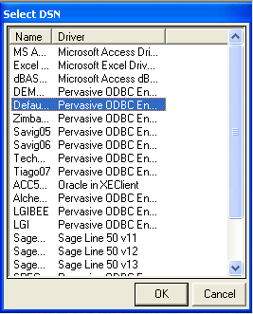
- Select from List; - This is the text that will appear in the popup box and you can change it to whatever you like. Remember to always end with “;”
- Only really useful when used with the straight PICKLIST= option, in other words you can safely leave the comments out if you wish provided you still end in “;”
PICKLIST=; MyCompanyA::DataA; MyCompanyB::DataB; MyCompanyA::DataA; - Defines your various database connections.
MyCompanyA:: - Is your descriptive name so anything goes – remember to end in “::”
DataA; - is the exact database name so it has to be exact – remember to end in “;”
NOTE – There is no “;” after the last database entry in the list.
Using the above, set up your own PICKLISTM= connection using your specific database names.
You now have your PICKLIST configured and we can move onto the next step.

B. Management Pack modifications
The next step is to set up our Management Pack in such a way that we will be able to see which accounts belong to which Company dataset in our Income Statement and Balance Sheet.
We do this by appending the Company name to the GL account number to ensure that each account number is unique.
Go to the Management Pack container in the Advanced Module and find the “MasterSubAccount” Expression.
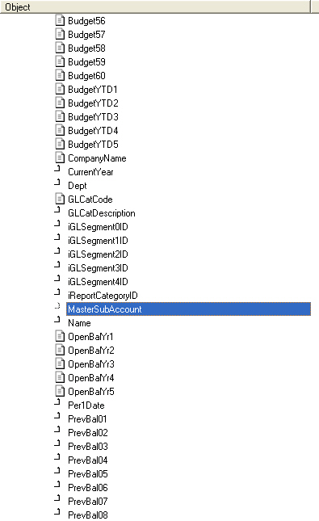

Change the expression properties as follows:
Expression Source:
[_bvGLAccountsFinancial].[Master_Sub_Account]+ '-' + [Entities].[Name]
Expression Type
SQL Expression
If you run a “Sample Data” you will notice that all your account numbers have the Company Name appended to it.
Keep in mind that if your Management Pack is of the Drill Down type (D) you will have to apply the same logic to the GL Transactions container as well.
Go to the GL Transactions container in the Administrator and make the following changes.
Go to Source Container type and change it to Join and add:
LEFT JOIN [Entities] ON [Entities].[Name] = [Entities].[Name]
To the bottom of the SQL join string.
Now find the “MasterSubAccount” expression and change the expression properties as follows:
Expression Source
[_evGLAccountsFull].[Master_Sub_Account]+ '-' + [Entities].[Name]
Expression Type
SQL Expression
If you run a “Sample Data” you will notice that all your account numbers have the Company Name appended to it.
This will ensure that your account numbers, used as the lookup comparator, has the exact same layout in the Balance sheet and the GL Transactions.

C. Run out the Management Pack
All we need do now is run out our Consolidated Management Pack. We do this as we would any other Management Pack except we are now presented with a selection of Companies to choose from.
Make your selections and click OK; the remaining steps will be exactly as per the usual Management Pack convention.
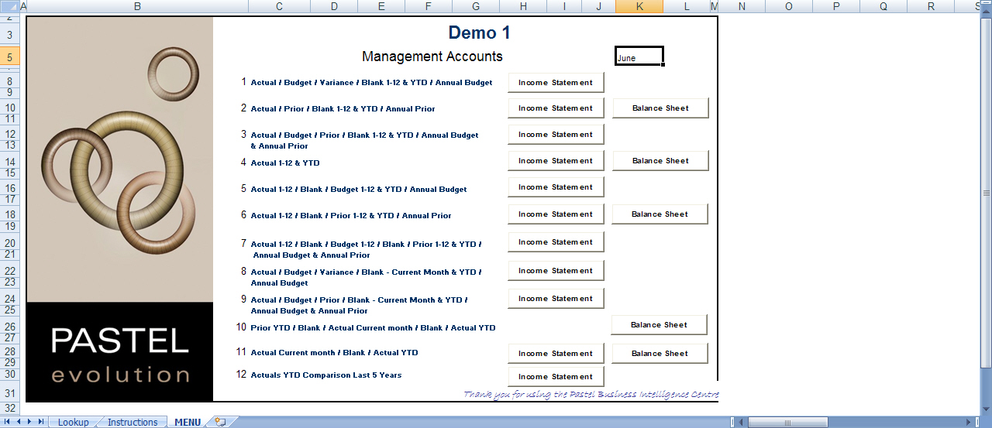
Once the report is run out you will have the same familiar Management Pack look and feel but with one important difference in that you can now generate Income Statements and Balances Sheets generated off 2 or more Company data sets, with the retained ability to drill down to GL Transaction Level details per Company.
You can further modify the layout of your worksheet in Excel if you wish, e.g. additional groupings and subtotals etc. but that’s optional and dependant on your specific needs.
Once you have run out your Income Statement you will see that an account exists for each Company that you have consolidated.


