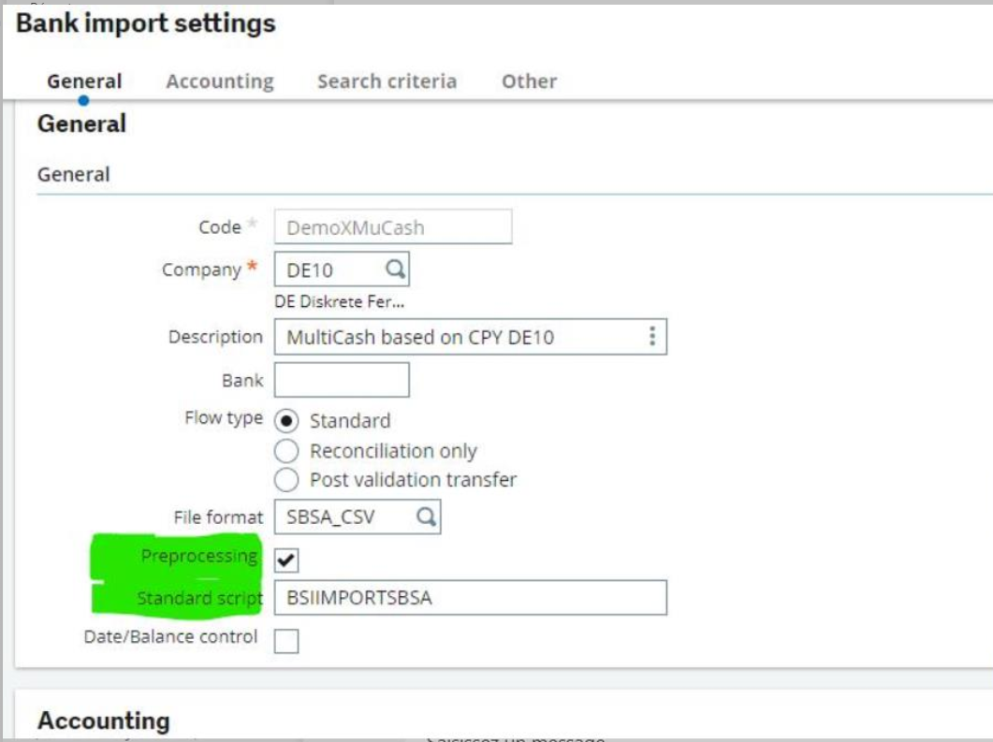

Overview
In order to handle unusual formats and/or specific data within a bank import file it is required to modify the file or the data using programmed code as the required modifications are beyond the capabilities of the bank import segment/file format definition.
We therefore foresee a possibility to run a linked process/function before the actual import to adjust the file.
The file(s) resulting from the preprocess will be processed from the Bank statement import process as usual.
The purpose of the preprocessing is to have files suitable to be imported by standard process. It is not a replacement of the standard process.
Preprocessing functions will either be delivered by R&D to handle specific formats or can also be created as a bespoke solution for a project.

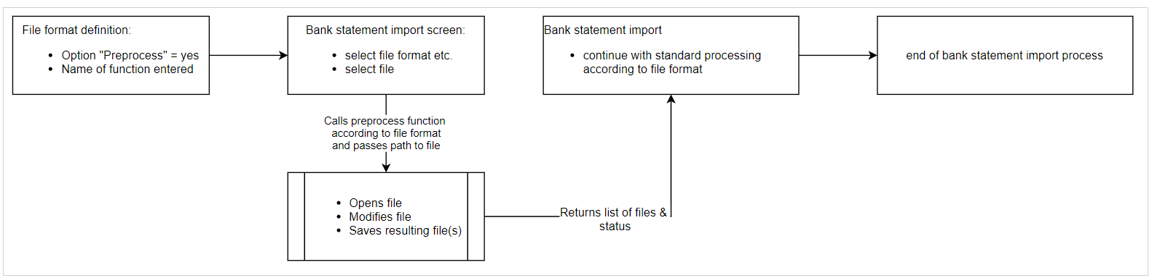

Interface and design of the preprocessing function
Input parameters
- path(!) and filename of input file
- Log file handle(?)
Other relevant information from the screen? Or do we just simply pass all field values to the function?

Return parameters
- List of files to be processed by the standard import
- Return status code (i.e. 0 = OK, 1 = error A, 2 = error B), extendable

Other considerations
- must be self-contained
- log output must be handled from the function but the BSI import opens the log file(?)
- resulting files must be written to the same volume as the original file

To define
- renaming/removing operations of original file handled by whom?

