THIS ONE WORKS: parameters work showing only companies selected, for the year and periods selected.

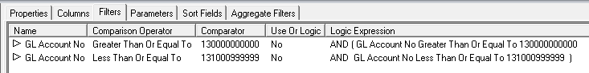

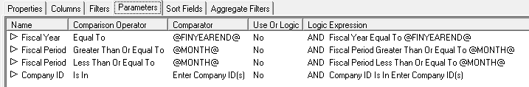

THIS ONE DOESN’T WORK: results in all companies, all years, all periods – parameters not working

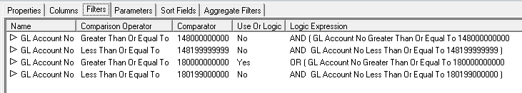

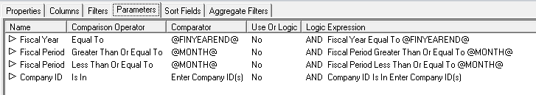

PARAMETERS FOR REPORT GENERATION FOR BOTH REPORTS:

