Ship Via and FOB screen shots, pre address validation:

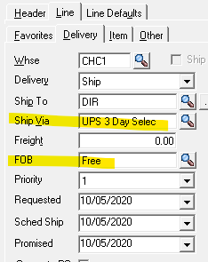

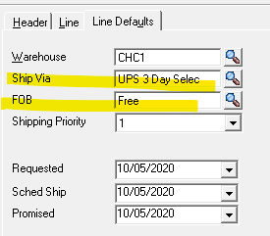

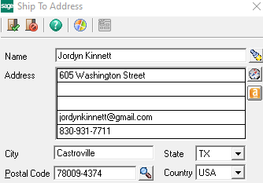

Address validated:

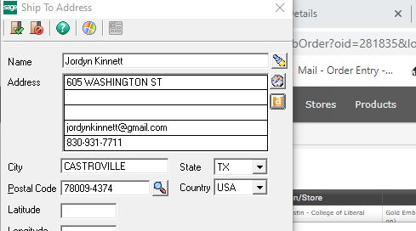

Pop up we receive after address is validated:

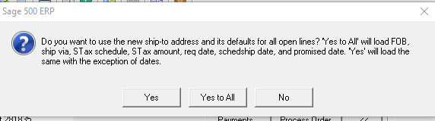

We select Yes, which changes the FOB and Ship Via back to the customer’s defaults on the Line/Delivery tab:

