“How To…” Guide

Setting up An Electronic Bank Transfer

Defining a Payment Method……………………………………………………………1
Setting up A Payment Transaction…………………………………………………………….2
Setting up A Bank File…………………………………………………………………...3
Setting up A Payment Term…………………………………………………………..…4
Setting a Bank Code…………………………………………………………………..…5
BP Payment Terms and Bank…………………………………………………….…….6
Processing and Payments Using EFT.………………………………………………………...8

Defining a Payment Method
Go to Common Data
BP Tables
Payment Methods
Table 3 becomes available
Add a Line
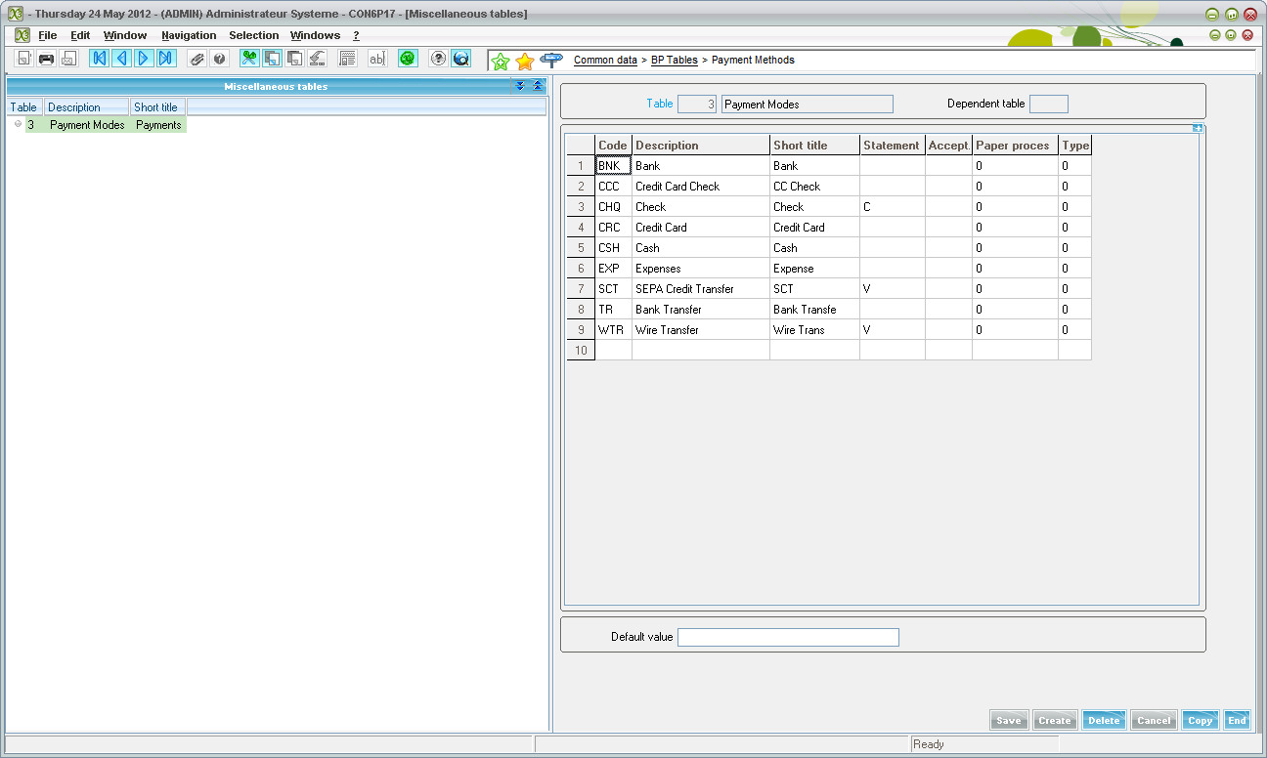
BNK with description “Bank” has been added to the table.

Setting up A Payment Transaction
Parameters
AP-AR Accounting
Payment Entry Transaction
BKTRF
Make sure the payment method is BNK
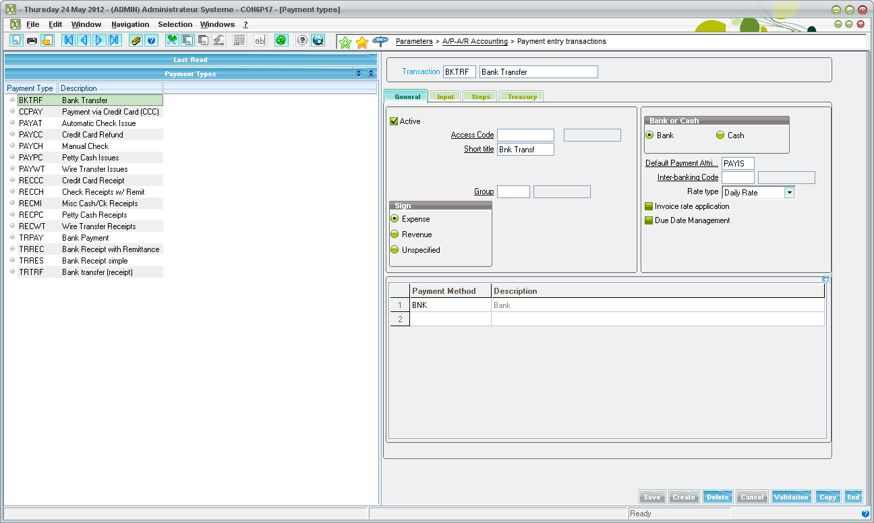
Then go to the Steps tab and make sure the “Remittances” and “Bank File” boxes are checked
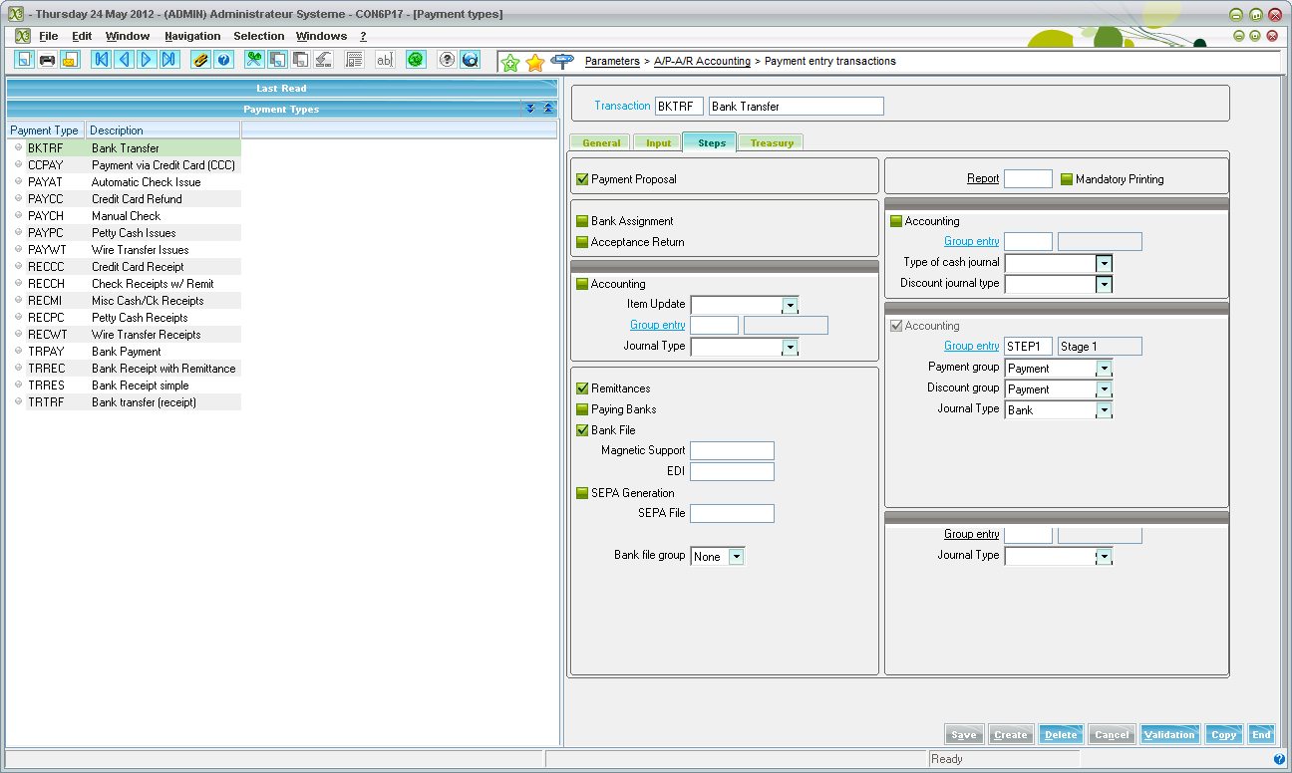

Setting up A Bank File
Go to Parameters
AP/AR Accounting
Files
Bank
New
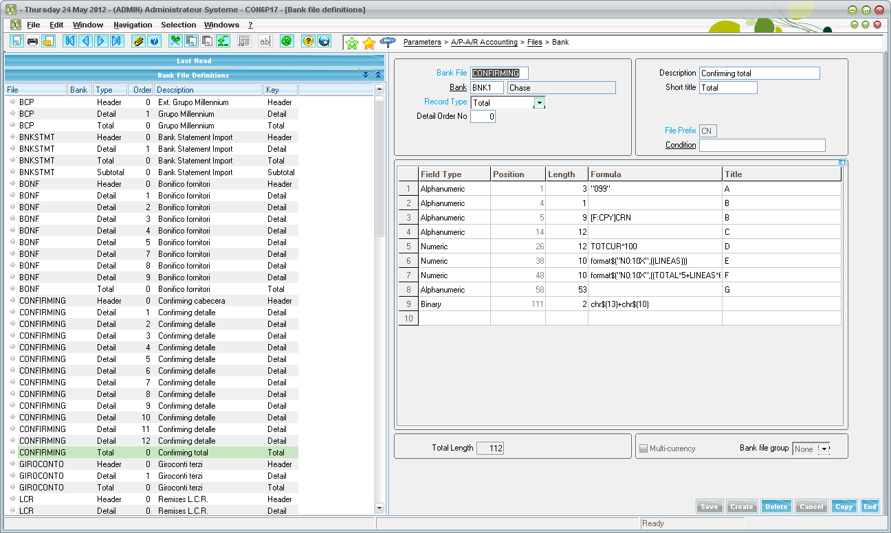
This is the file that will be used for sending the file to the bank.

Setting up Payment Terms

Go to Common Data
BP Tables
Payment Terms
New

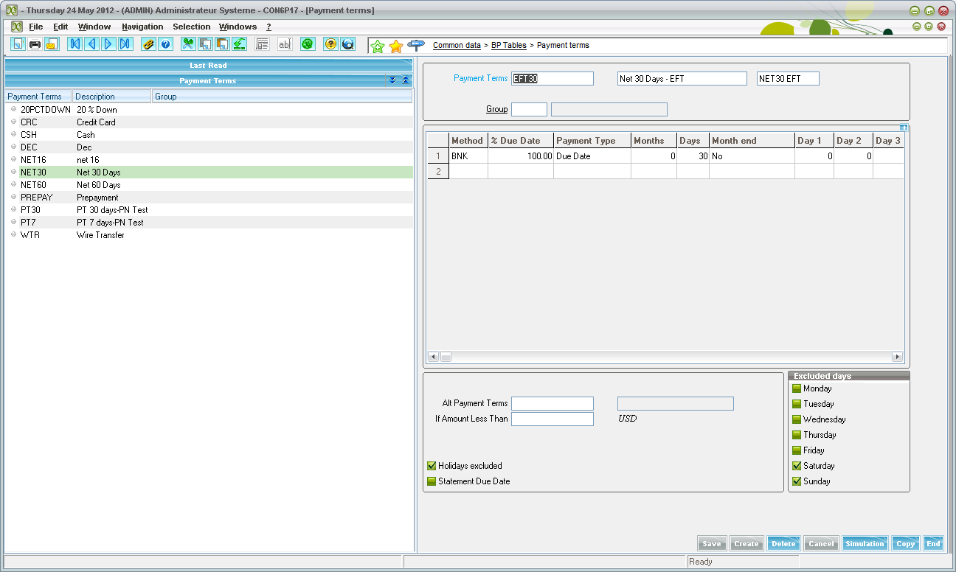
The method of payment must be the payment method created in Payment Methods

Setting up a Bank

Go to Common Data
BP Accounting Tables
Bank Accounts
Click “New”
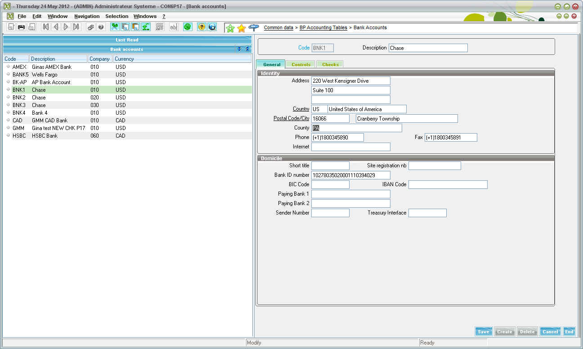
Make sure to include an address and a Bank Account number.

Controls Tab
Journal code and Accounting codes are mandatory.
A file extension must be included on the record if this is the bank that will be doing the bank transfers.
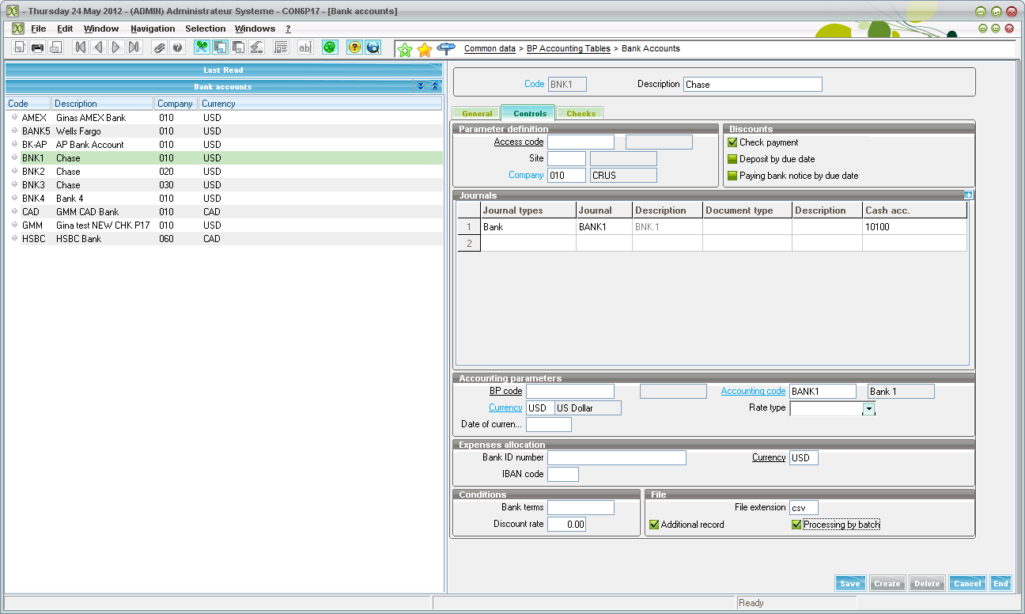

BP Payment Terms and Bank
Go to… Common Data
BPs
Suppliers
Financial Tab
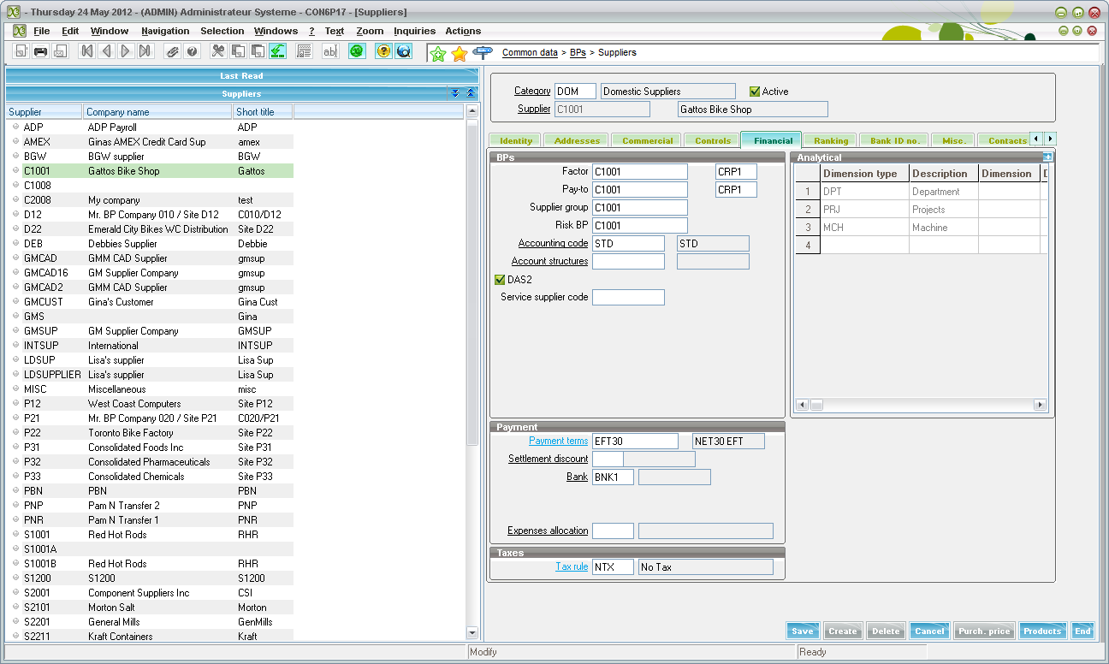
Make sure to add the correct payment terms to the supplier.
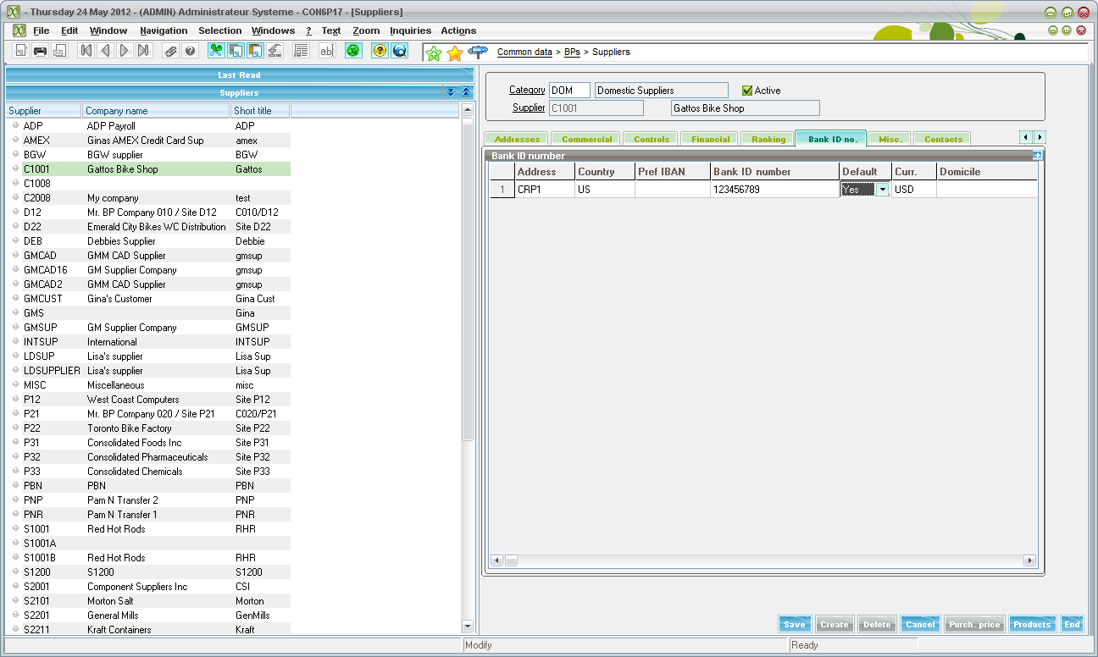
Bank ID No. Tab
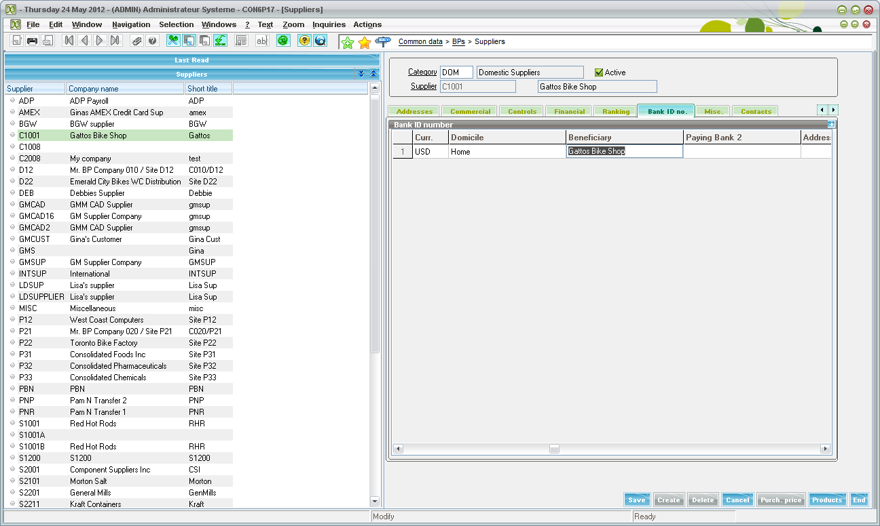
Make sure to add bank information for the BP

Processing and Paying Invoices in X3 with EFT

Entered and posted the following invoice (AP-AR Accounting-BP Invoicing-Supplier Invoicing)
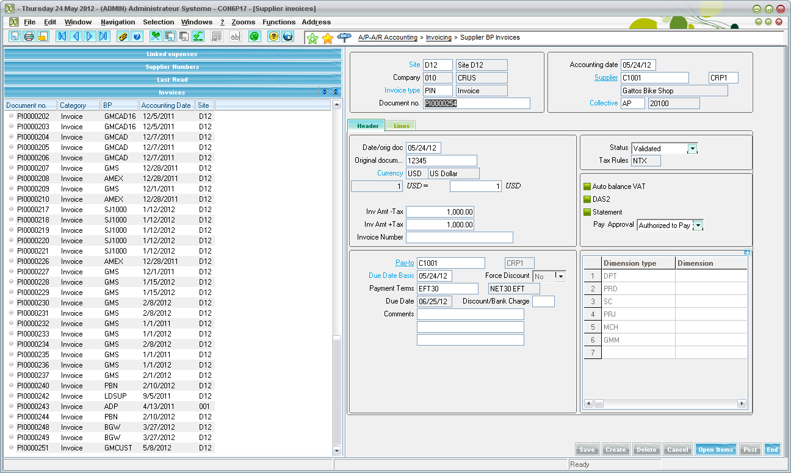

Run payment proposal
AP-AR Accounting
Payments
Payment Proposals
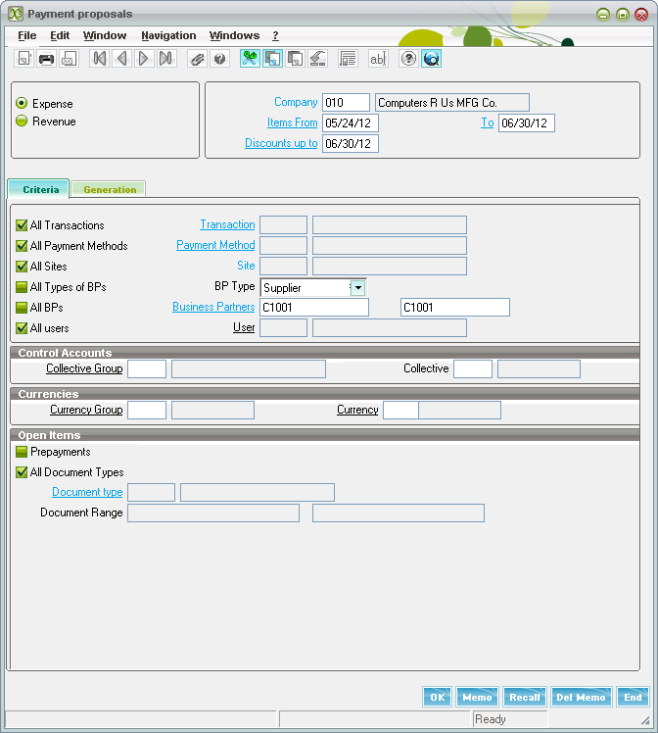
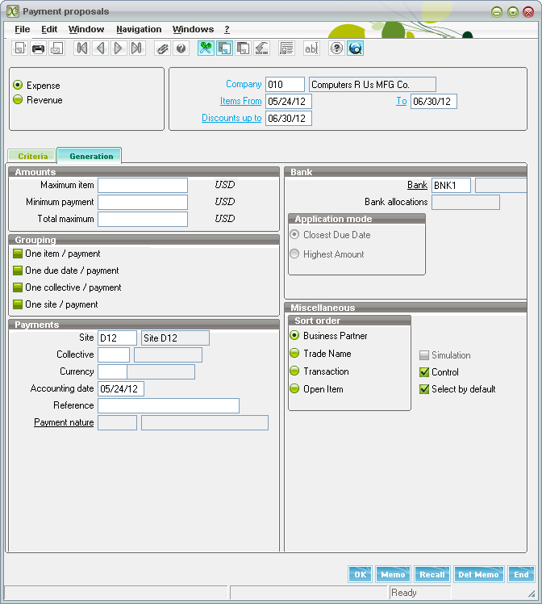

The payments below are separate because they have different payment types so each will be created in a different transaction screen.
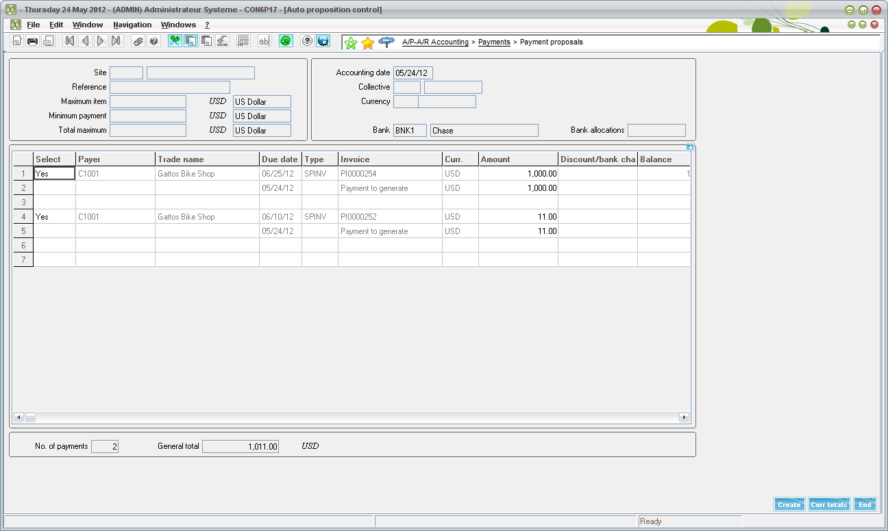
Here is the transaction created in the following BKTRF screen
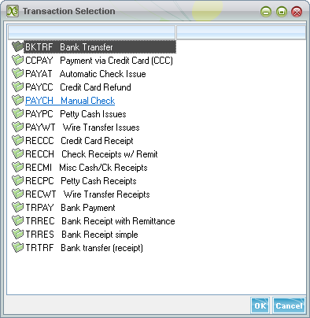
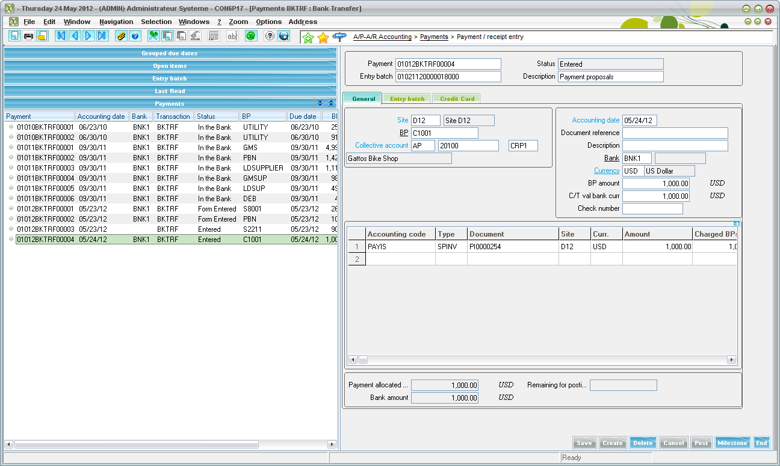
Create the automatic remittance creation
AP-AR Accounting
Remittances
Automatic Remittance Creation or Manual Remittance Creation
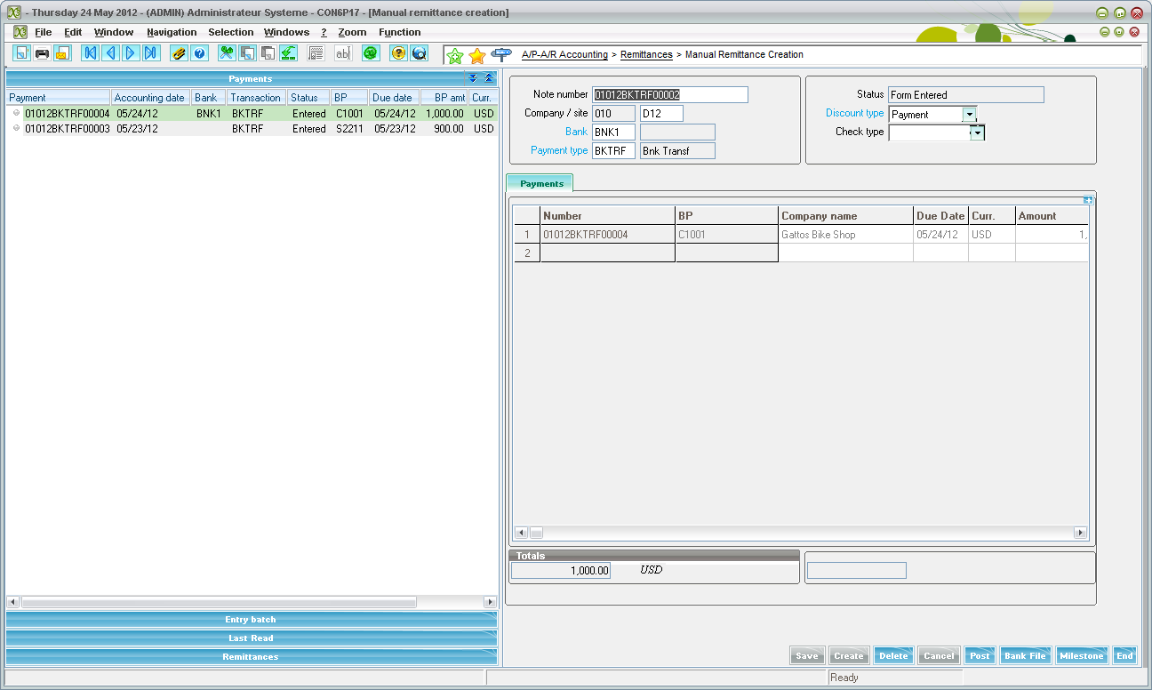

The bank file can be transmitted the following way
Clicking the “Bank File” button at the bottom of the screen
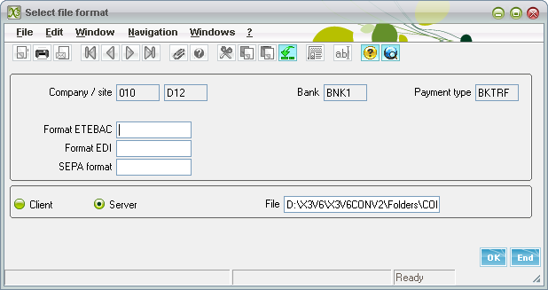
Post the payment.

