How to change database collation using SQLCMD
Sometimes, it is discovered after installation, that an application database has been created with a wrong collation method, either through ignorance or inattention.
Re-installation may not be an option as it may be prohibitively expensive or impractical for other reasons. If you find yourself in this embarrassing situation, this article describes a method of addressing this situation and will save your reputation or from much worse.
- SCRIPT THE DATABASE and DATA
Using SSMS, select the SEI database > Task > Generate Scripts,
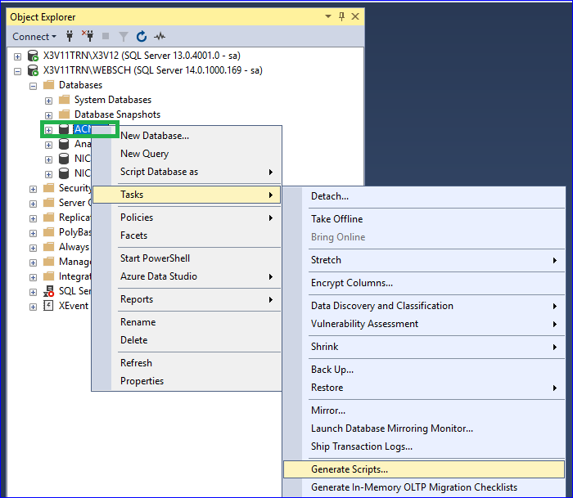
Next
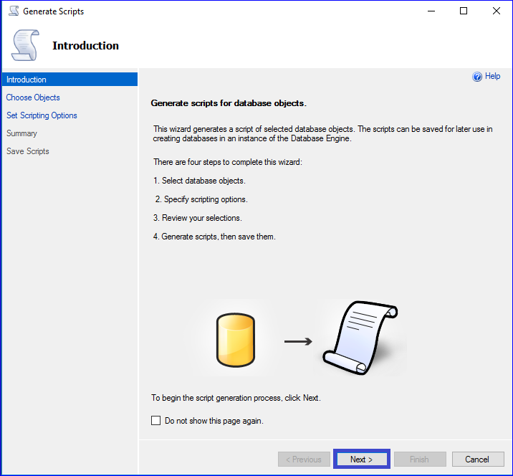
Script entire database and all database objects, Next
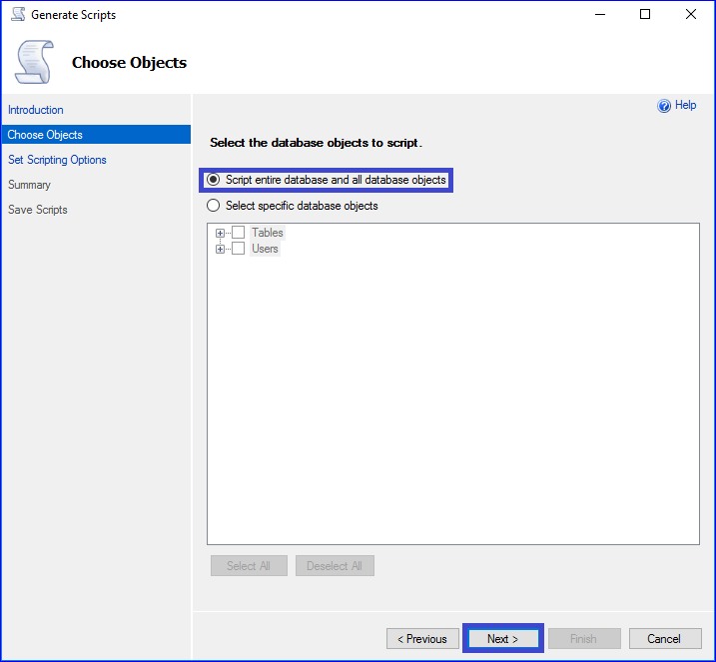
Click “Advanced”
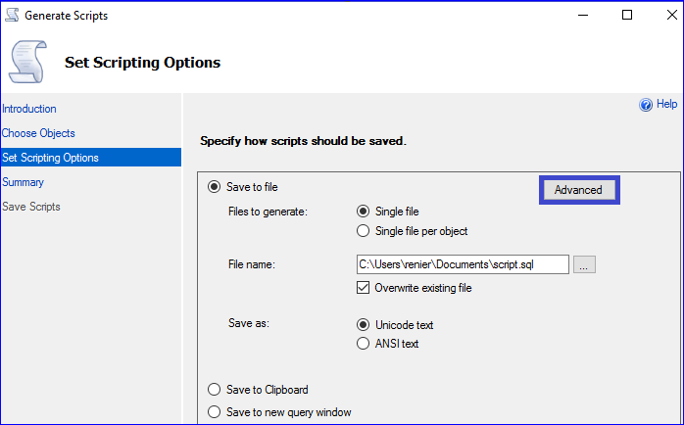
• Change Script Collation: True.
• Change Type of data to script: Schema and data.
• OK to close window
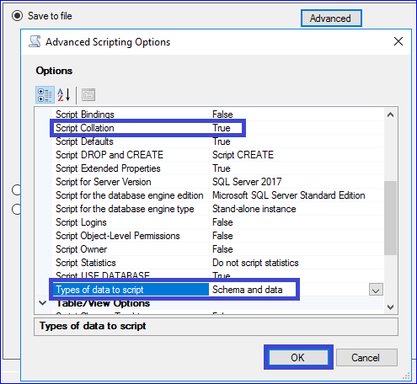
Change File name: C:\TEMP\necscript.sql
Next
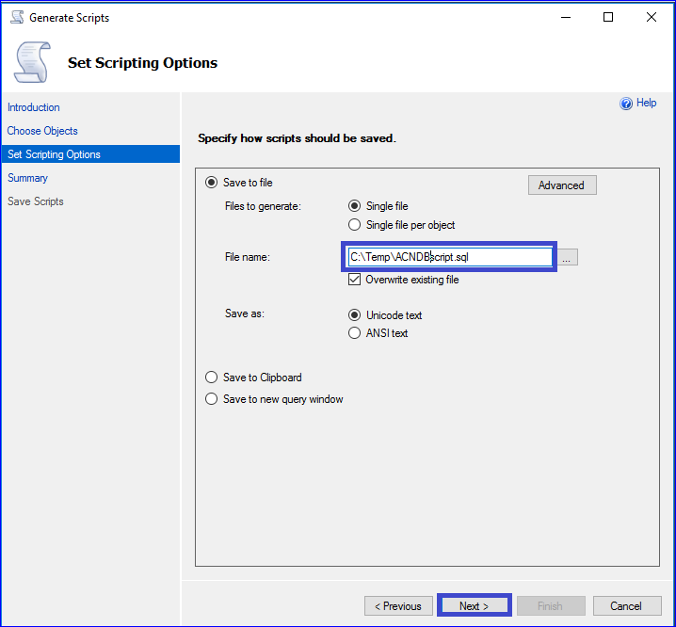
Next
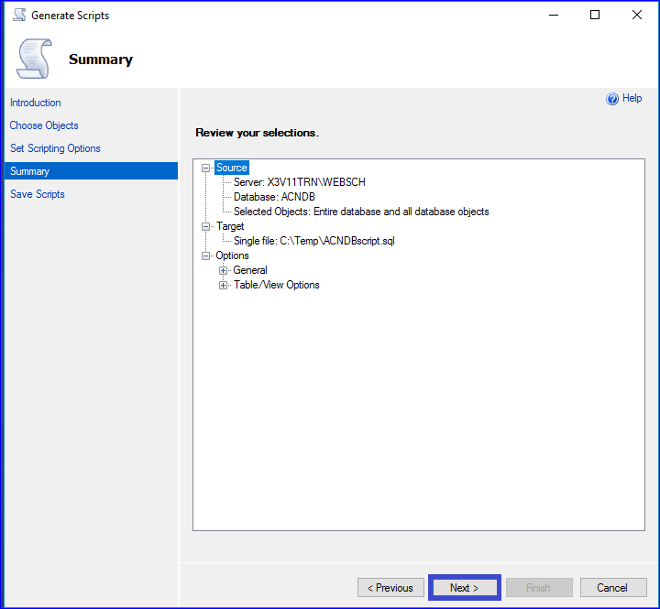
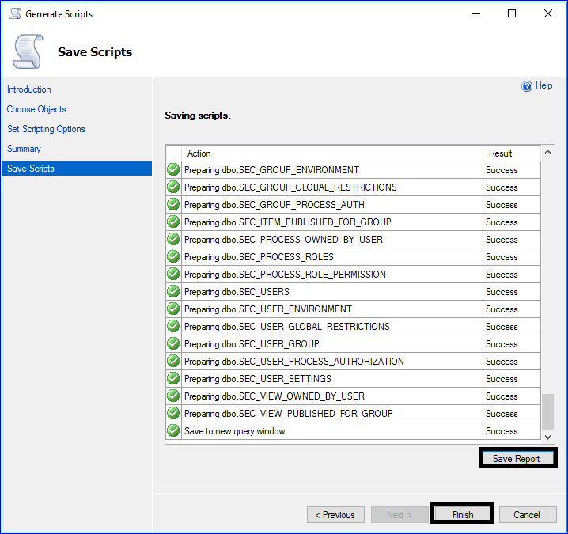
- BACKUP AND REMOVE or RENAME the target database
Backup the current target database.
Once completed, either completely delete the existing target database, or detach it and rename its .mdf and .ldf files.
- REPLACING THE COLLATION:
Edit the script C:\Temp\ACNDBscript.sql
- Search and replace all collation occurrences with desired collation method. e.g. Latin1_General_BIN
- Save the script.
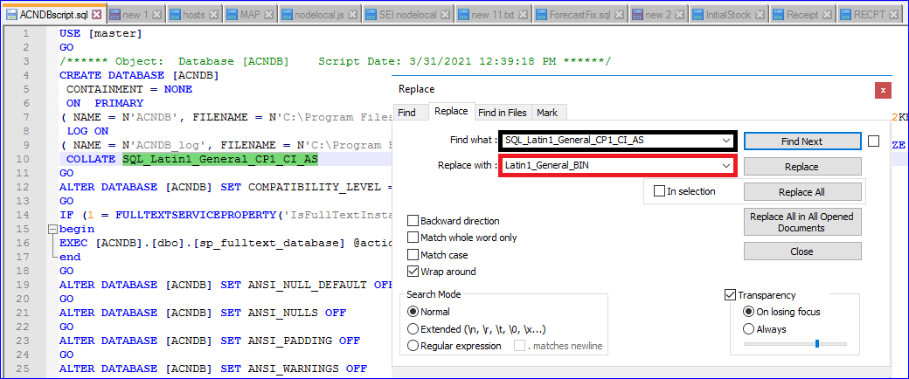
- EXECUTE THE SQL SCRIPT THROUGH COMMAND LINE (using SQLCMD)
Why? Because when loading data, sqlcmd proves to be more reliable than executing the script directly in SSMS, which often times out, with an error.
- Start the command line in Administrator mode
- Go to the place you saved the script: CD C:\TEMP\ACNDBcript.sql
- Adjust the below command line to your own scenario and execute it:
[ sqlcmd -S X3V11TRN\X3V12 -U sa -P passw0rd -i C:\Temp\ACNDBscript.sql ]
[ sqlcmd -S SQLSERVER\INSTANCE -U SQLUSER -P SQLPASSWORD -i C:\TEMP\ACNDBscript.sql ]
- The script will create the database and load the records one by one.
If successful, it will normally end with:
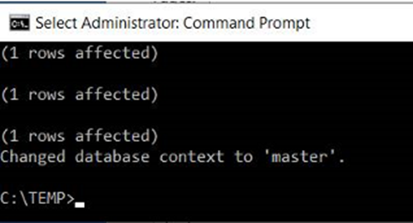
I hope

