Purging

There is a need to purge batch server job records to ensure the batch server tables and log files do not grow too big and start causing issues with performance. With tasks such as Accounting Tasks and Workflow Signatures which may be running every minute or so, the number of records in the batch tables can grow very quickly.
• NOTE :for all purging methods available, although all task log files will be removed as well as the records from the database tables, you still need to manually archive the “serveur.tra” file, located in directory “..\Folders\X3\SRV\TRA”

Purging
Purge historic batch server records
• Connect to X3 folder as batch server tables are in the X3 schema – Parameters, Usage, Data, Purge Parameters
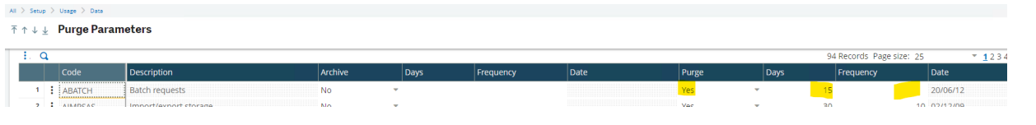

Purge historic batch server records
• Configure a recurring task to run as required:
• Usage, Batch Server, Recurring task

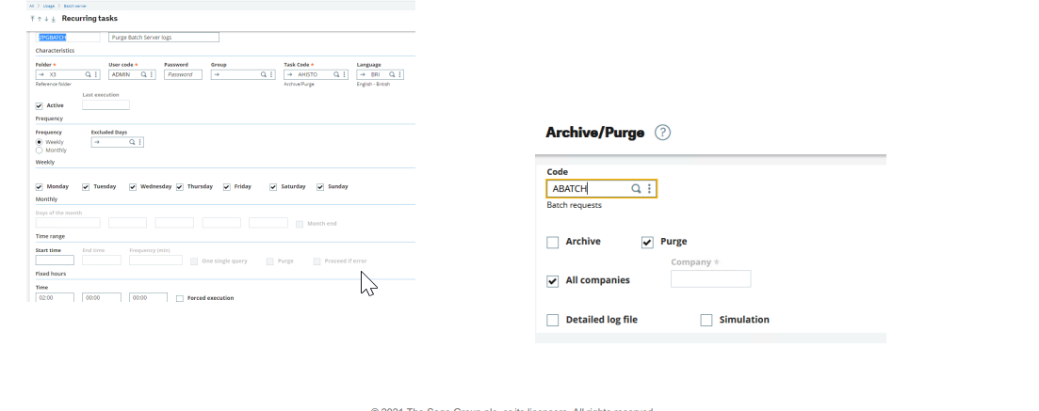
Recurring tasks allow you to specify that batch server records are automatically purged on success of the task.
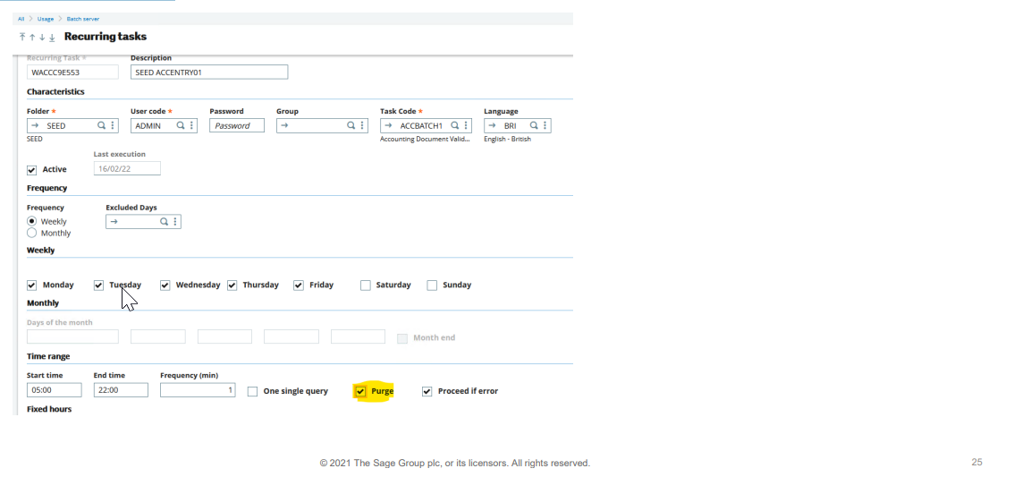
Purging
“Purge” option available from the Query management screen
