Expense creation from fixed asset
When as asset is imported or created manually with a value in the balance sheet the capitalize button is not active.
Before V12 patch 26 An expense could be added to an existing asset only if:
- The asset is not valued (no value in the balance sheet)
- The asset is linked to an expense (while creating the asset, before you hit the create button, you add an expense with the capitalize button)
Expense creation utility was added to make it possible to create an expense for a standalone asset (not linked to an expense) that was created manually or imported automatically.
This is a bulk process that allows users to select assets that are not linked to expense based on custom criteria. For each asset, an expense is created and linked to the asset using the relevant fields.
Fixed assets>Utilities>Expense creation
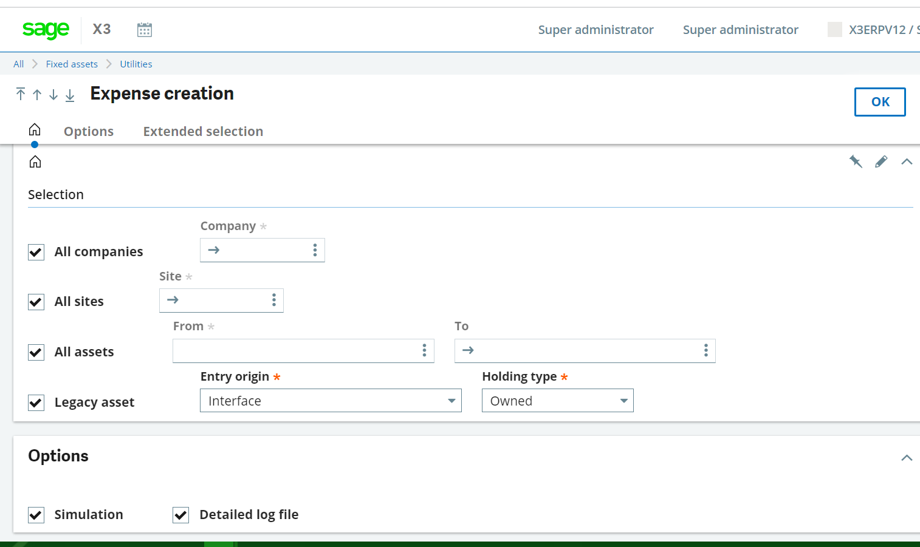

Process
Create an asset manually without linking the asset to an expense.
The asset must be valued (with a value in the balance sheet)
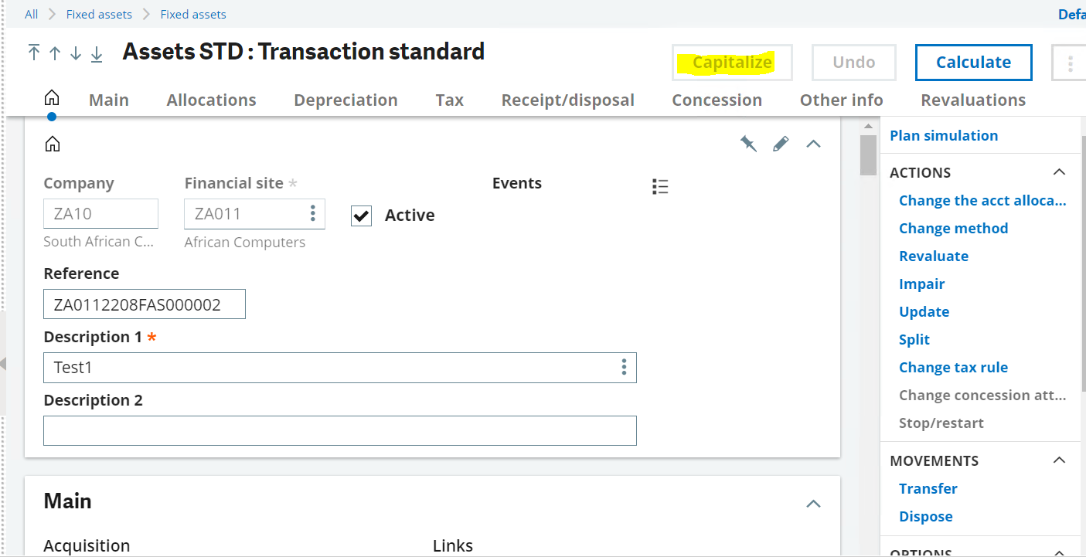

Go to Fixed assets>Utilities>Expense creation

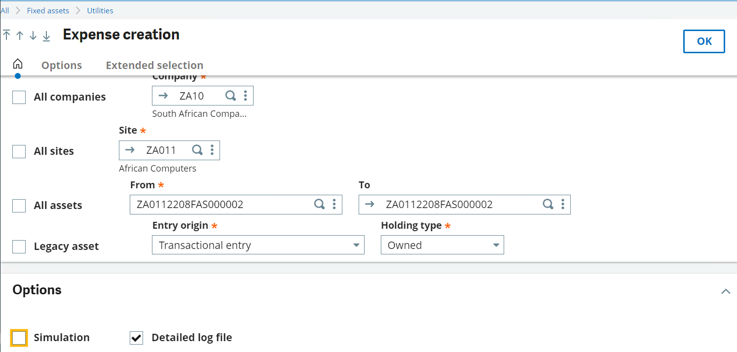

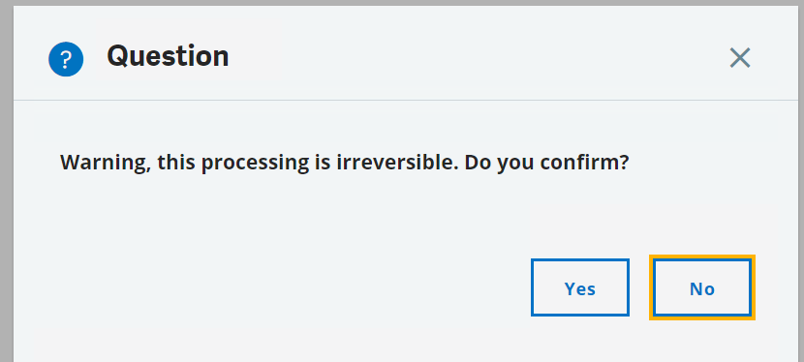
The log shows the expense code created

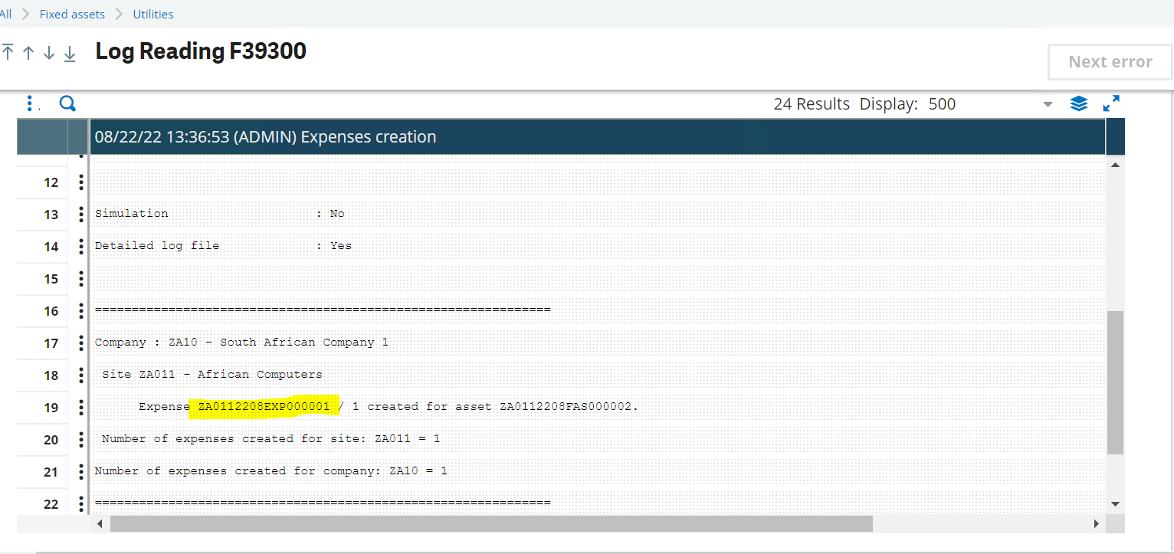
The expense created with asset details, linked to the asset and is set as principal expense.
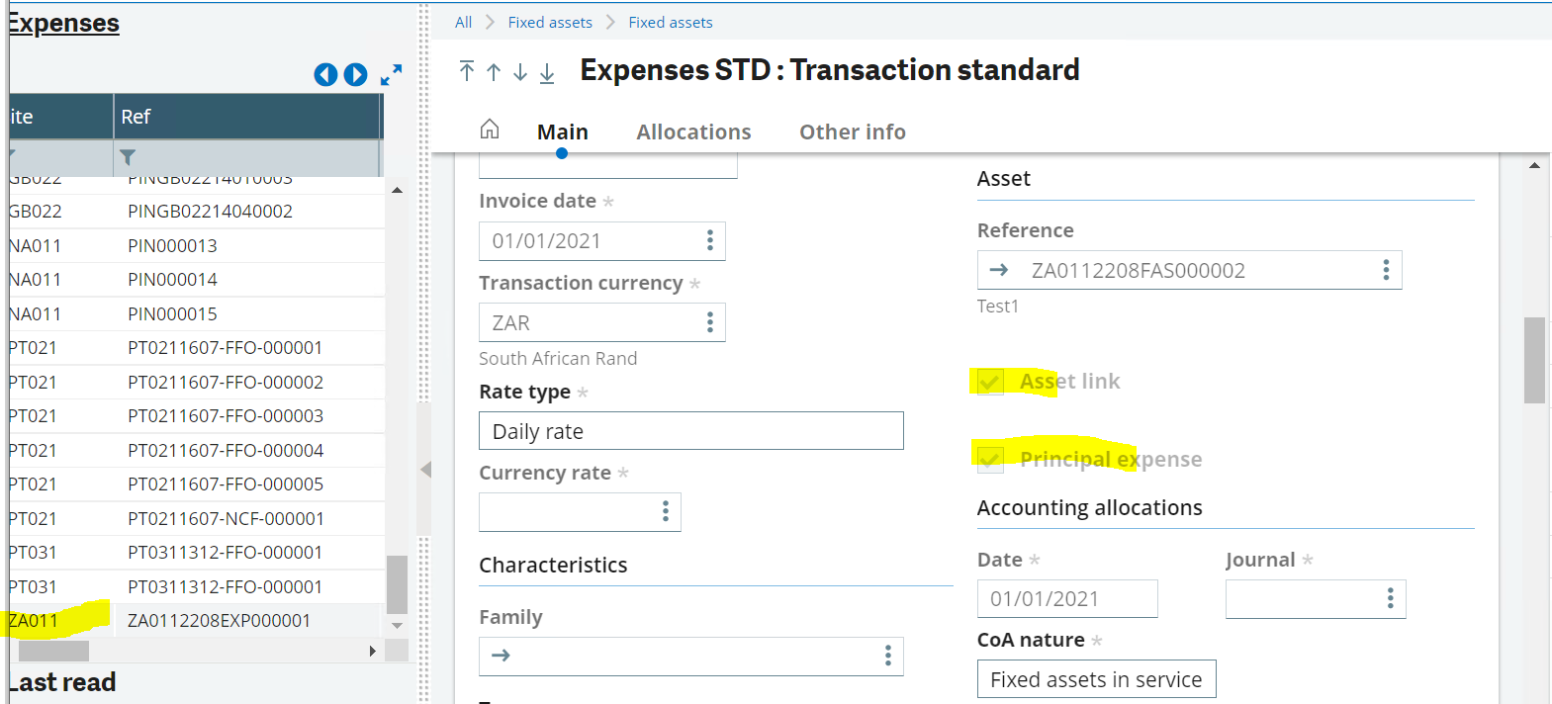
The capitalize button on asset screen will now be active
After clicking the capitalize button the expense shows under remaining expenses.
