Incorrect reconciliation when reconciling bank entries.

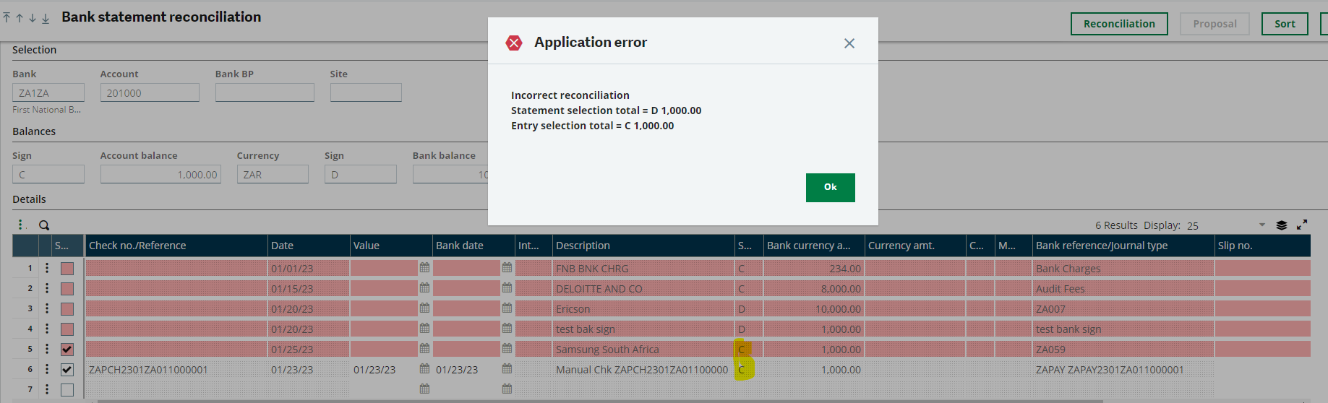

Incorrect reconciliation
Statement Selection total = D 1,000.00
Entry Selection total = C 1,000.00

Reason:
Parameter SNSBNQ (Bank Sign) in Chapter :TRS, Group: BNK is not setup according to how the matching is done.

Solution:
The parameter SNSBNQ is used to define the display sign of the postings on the statement in the bank statement reconciliation table:
- Yes: the postings on the statement are displayed with the bank sign.
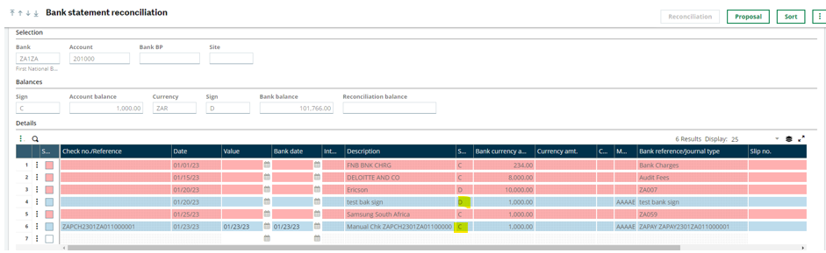
- No: the postings on the statement are displayed with the accounting sign.
