- Create a new batch and select a warehouse in Process Physical Inventory. Select 'Show Frozen Qty's' to view the frozen quantity during Enter Counts, under Review.
- Select 'Count Items'. First, click the 'Options' tab to review before proceeding with the selection.
Note: Selecting to include 'Items with Zero Quantity On Hand' selects all items (in warehouse) with zero quantity. The selection criteria is not applied to the zero quantity items.
- Freeze the items to be counted. After a batch is frozen, the freeze date and time display on the batch window and this option becomes disabled. The Windows system date is used.
- Print the count cards or count sheets used to enter the counted quantities for each item. Items display on the count cards according to their bin location, lot and serial number when used.
- Click on ‘Enter Counts’ button then on ‘Apply’ button with counted and uncounted items included as shown below.
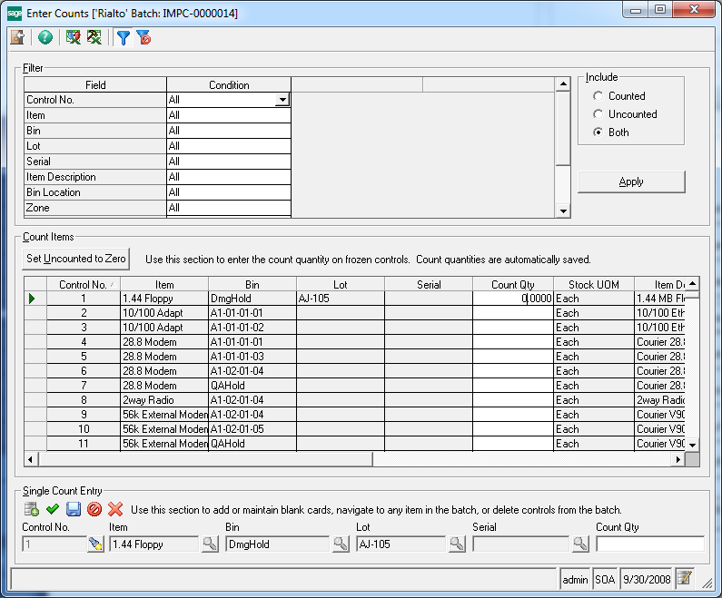
- Using the right mouse click export the grid to Excel and save it.
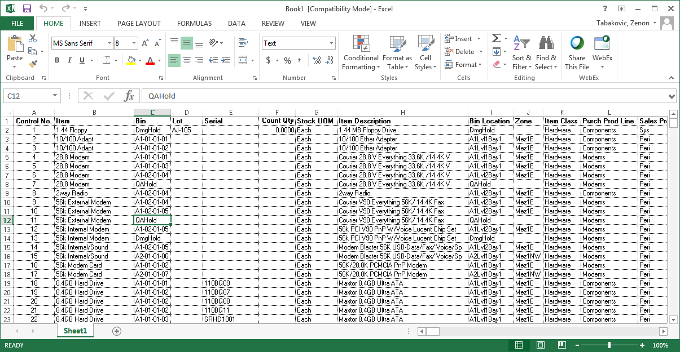
- Launch Data Porter using Alt-F7 or clicking on Data Porter icon, click on ADD-INS tab, and then ‘Map Controls’ icon. You will get the blank sheet, see below:
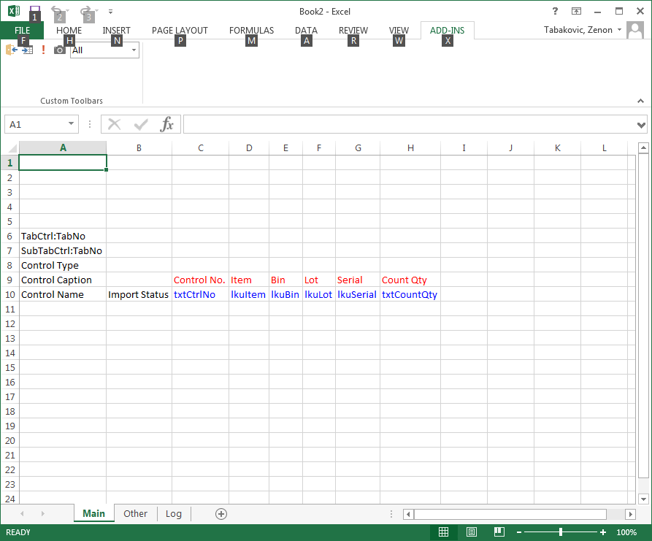
- Populate the sheet by copying the data from the first sheet (exported data). You need to copy only the following fields: Control No, Item, Bin (if warehouse is using bins), Lot (if item is tracked by lot), and Serial (if item is tracked by serial number). Save the sheet and distribute it to the warehouse where physical counts are entered.

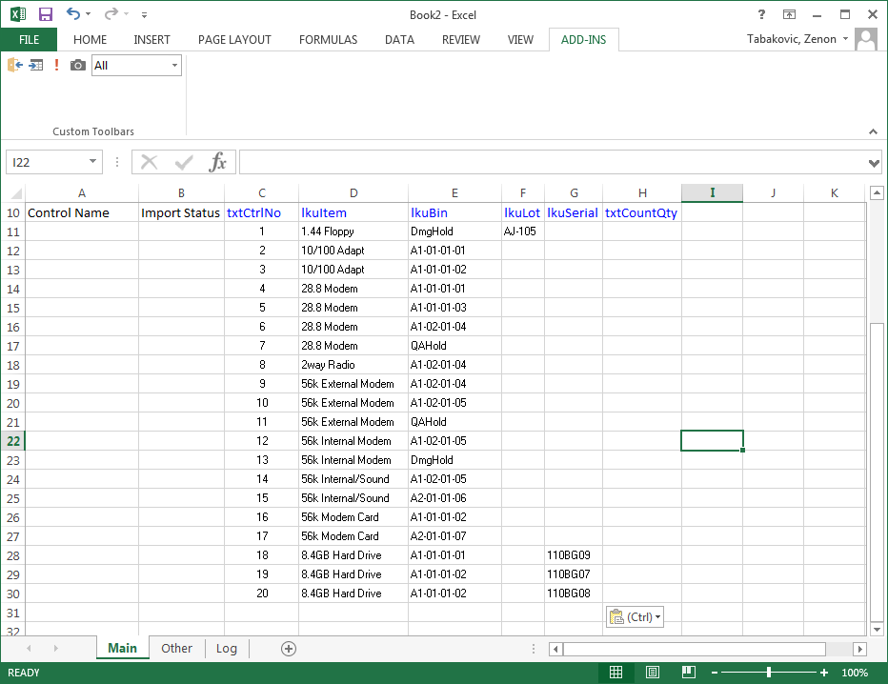

- Have your counters enter the counted values for each item/bin/lot/serial number combination and save the sheet.
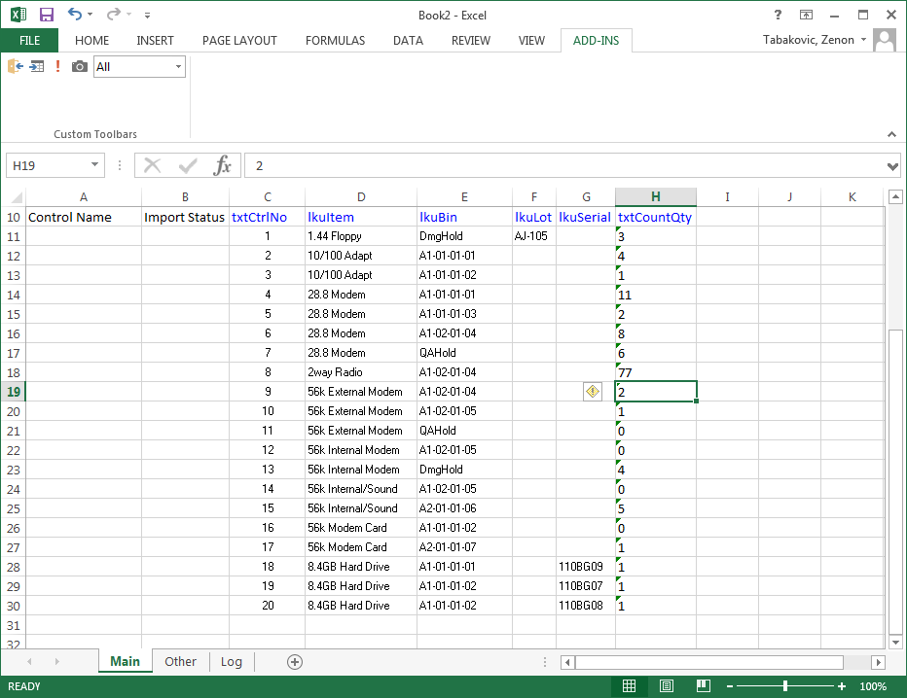

- Reopen your physical count batch, click on ‘Enter Counts’, launch Data Porter again, click on ADD-INS, Map Controls and copy/paste data from the sheet where counts were entered (see the last sheet above). Once all the data has been pasted and aligned correctly click on ‘Import Data’ icon (exclamation sign) and allow the data to be imported into Enter Counts grid.
- All items that were found in the warehouse and could not be related to the exact item-bin-lot-serial number combination as it was frozen can be added using blind cards by using Single Count Entry section and clicking on Add Records icon, selecting the item, bin, lot and/or serial number.
- Print a report of any missing count card using the 'Missing Count Cards' function.
- Print the Reconciliation Report to verify the information entered and view the variances. Print this report to view transactions that affected the inventory balances of the items frozen for the physical count process. This displays all transactions that posted after the 'Freeze Date and Time'.
- Print the Discrepancy Report to view the items whose physical count and on-hand quantity is greater than the tolerance percentage defined in Set Up IM Options.
- Print and post the batch to update your inventory quantities and value. Make the necessary adjustments to General Ledger.

