Sage Enterprise Intelligence: How To example on populating the Map table used by the SEI Sales Cube so Longitude and Latitude can be plotted on Map style worksheets

NOTE: This is provided “as is” for an example of how to populate the data mentioned. There are other options, use the one best for your business. This is not a process supported by Sage Customer Support.
WARNING: Always back up data prior to making changes
Prerequisites:
- Ability to get a Zip code database
- Intermediate skill with Microsoft Excel
- Access to Microsoft SQL Server Management Studio
Process steps
Download a Zipcode database
Example is a free 2012 database of US Postal codes. There are commercially available, update to date, databases which can be purchased online from third party vendors.
http://federalgovernmentzipcodes.us/
Database Updated: 1/22/2012
Free Zipcode Database (8.7 MB) Updated 1/22/2012 All Locations (Multiple locations for some zipcodes)
Extract and open
Identify source file format
Target table is MAP table in the SEI_[x3Folder] schema. In this example, SEI_SEED
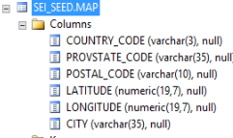
Convert source file to base format of MAP table
Desired columns highlighted:
Deleted unnecessary columns
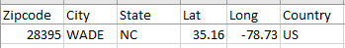
Sort source file on country
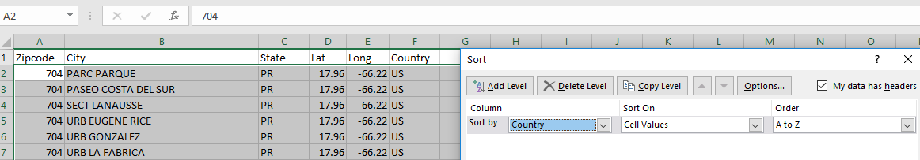
Delete rows which show military APO/FPO addresses and are missing Longitude and Latitude coordinates. (I also deleted all Puerto Rico rows.)
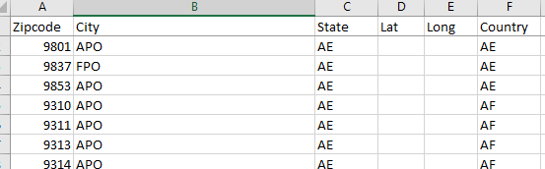
(Save file as Excel sheet.)
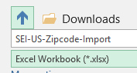
Changed Zipcode column to Text format
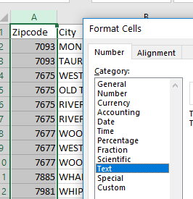
For New Jersey, insert one zero “0” in front of zip codes in new column.
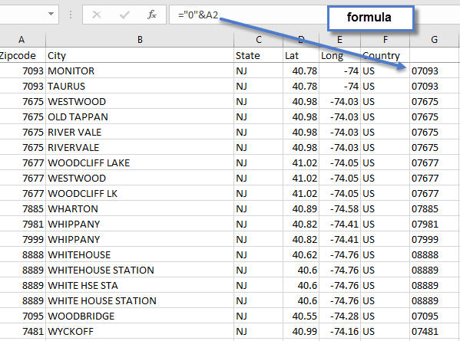
Copied and Paste Special, Values from Column G to Column A for New Jersey
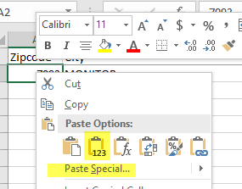
Delete column G
Save spreadsheet
Order columns to match MAP table order
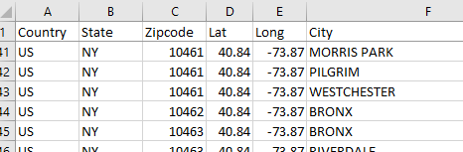
Combine columns into a single column string for an Insert statement in SQL
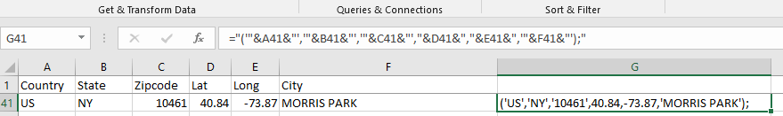
Example Formula: ="('"&A41&"','"&B41&"','"&C41&"',"&D41&","&E41&",'"&F41&"');"
Note the all text fields are enclosed with a single quote ‘. So the formula has several places where it is double-quote single-quote comma single-quote double-quote. Example (spaces added): “ ‘ , ‘ “
Once the formula is copied into all rows (this example has around 81,300 rows), then copy the column and Use the Paste Special – Values to paste it back on to itself so the formulas are replaced with text.
Delete columns which have the original data (A-F in this example)
Delete row 1 which is blank
Insert 3 columns to the left of the one with the data in it
Break this command into the 3 columns. This will allow you to replace the folder specific value if you want to import into more than one SEI schema.
Insert into SEI_SEED.MAP (COUNTRY_CODE, PROVSTATE_CODE, POSTAL_CODE, LATITUDE, LONGITUDE, CITY) values
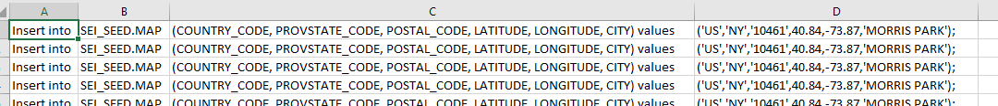
Copy formula to all rows
Save spreadsheet
Once more combine all the columns into a single column [E].
Copy / Paste Special – Values that new column [E] onto itself
Save spreadsheet
Delete columns A – D (in this example)
SAVE AS a different name, like “SEI-US-Zipcode-Import-SEED”
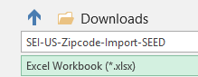
Next SAVE AS a CSV file format
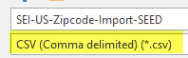
Browse in Windows and change the file extension to .SQL
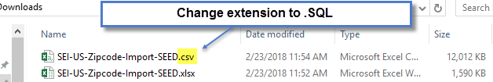

Open File in SQL Management Studio
Note the leading and ending double-quotes
Ctrl+F
Quick Replace (Ctrl+H) or File, Edit, Find and Replace, Quick Replace
Replace “Insert with Insert
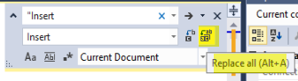
And ):” with ):
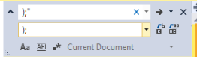
Select the SEICube and click Execute to insert the long/lat data into the MAP table.
